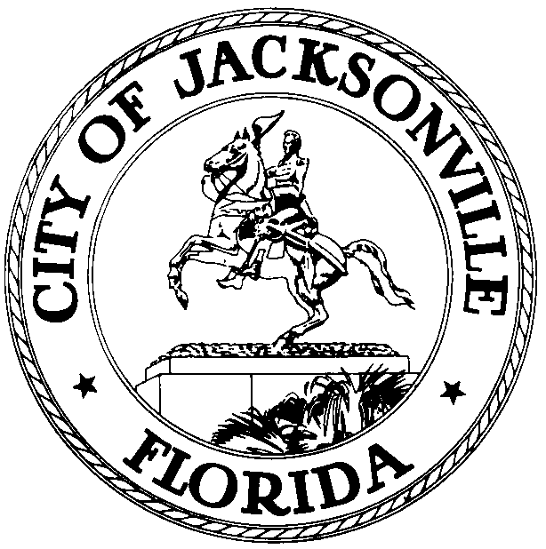

OFFICE OF THE CITY COUNCIL

HONORABLE TOMMY HAZOURI 117 WEST DUVAL STREET
CITY COUNCIL PRESIDENT 4TH FLOOR OF CITYHALL,SUITE 425
AT-LARGE, GROUP 3 JACKSONVILLE, FLORIDA 32202
OFFICE (904) 255-5217
E-MAIL: thazouri@coj.net

AMENDED IN-PERSON NOTICE
APRIL 27, 2021
9:30 AM

AMENDED IN-PERSON NOTICED MEETING COMMITTEE OF THE WHOLE
RE: LOCAL OPTION GAS TAX & SEPTIC TANKS
MAY 12, 2021
2:00 PM – 5:00 PM

Members of City Council
City of Jacksonville
Jacksonville, Florida

Physical Location: Council Chambers
City Hall
117 W. Duval Street
Jacksonville, Florida 32202

(If attending virtually, please join the meeting by 1:45 PM)
Meeting ID: 916 7597 4578
Passcode: 785186

Pursuant to Council Rule 2.105, the Honorable Tommy Hazouri, President of the Jacksonville City Council hereby calls an Hybrid Virtual/In-Person Committee of the Whole Meeting for Wednesday, May 12, 2021, 2:00 PM – 5:00 PM, in the Council Chambers located in City Hall, First Floor, 117 W. Duval Street, Jacksonville, FL 32202. The purpose of the Noticed Hybrid Virtual In-Person Meeting to provide a forum to discuss Ordinance 2021-0223 (Local Option Gas Tax) and Ordinance 2021-0235 (Septic Tanks).

Beginning May 11, City Council will return to in-person meetings for all Council Members and the public. The meetings will be broadcast (FOR VIEWING ONLY) on Comcast Channel 99, AT&T Uverse Channel 99 or Streaming via https://www.coj.net/city-council/city-council-meetings-online, or Zoom Application (VIEWING ONLY).

Members of the Jacksonville City Council, and other elected or appointed members of Boards and Commission, and other interested parties are invited to attend. In-person attendance by members of the public is necessary to participate in public comment or public hearings.

Council Members, if you are unable to attend in person, please send your excusals to the Council President in order to ascertain quorum for the meetings. No virtual attendance will be permitted for Council Members or participants.

The meeting noticed herein for Monday, May 24, 2021, 3:00 PM – 4:30 PM can be accessed as follows:

- You may attend the meeting in-person at the physical location- City Council Chambers, but CDC guidelines will be adhered to due to COVID-19. Concurrent with the expiration of Mayor Curry's Emergency Executive Proclamation 2020-005, any member of the public entering City-owned public buildings may choose to wear a mask inside the building. Council strongly encourages the use of masks for all employees and visitors, especially when social distancing at 6 feet (or more) is not possible. Council will make masks available for visitors and the public.

- You may attend the meeting virtually (for viewing only- no participation in public comment or public hearings).

- The public is encouraged to share general comments with individual Council Members by email or telephone. CCMeeting05252021@coj.net is the designated email for comments from the public.

WAYS FOR THE PUBLIC TO ACCESS THE MEETING:

- Sign up for Zoom. Type - Zoom.US – with Chrome Internet Browser.
  - Go to: "Join A Meeting" on Dashboard
  - Enter the Meeting ID: 916 7597 4578 Passcode: 785186

- Watch meeting via Stream Source on computer. Streaming site (or COJ streaming site): https://www.coj.net/city-council/city-council-meetings-online

- Join Zoom Meeting by Phone:
  - Dial - 1 (301) 715-8592 or find a local number: https://zoom.us/u/acgmEl2oI
  - Enter the Meeting ID: 916 7597 4578 Passcode: 785186

- Watch meeting on Comcast Channel 99 or AT&T Uverse Channel 99 or https://www.coj.net/city-council/city-council-meetings-online

- Watch the digital recording later via the City Council website.
  - Click link: https://www.coj.net/city-council/city-council-meetings-online
  - Go to "Available Archives" and click "City Council."

JOINING A MEETING BY DIAL-IN PHONE ONLY

- Dial the phone number listed above. If you dial a toll number, carrier rates may apply.
- You will be prompted to enter the Meeting ID and Passcode:
- Enter the Meeting ID: 920 6091 8271 Passcode: 916751
- If the meeting has not already started and "Join before host" is not enabled, you will be prompted to press # to wait if you are a participant.
- You will be prompted to enter your unique Participant ID. This only applies if you have joined on the computer or mobile device or are a panelist in a webinar. Press # to skip.
- If you join by computer or mobile device later, you can enter the Participant ID to bind your phone and device session together and show your video when you speak on the phone.
- To enter your Participant ID, enter #Participant ID# on your phone once you are in the meeting.

ACCESS TO CITY COUNCIL MEMBERS:

1. Make Comments IN-PERSON.
2. Email your comments to CCMeeting05252021@coj.net
3. Contact Council Members directly by phone or email. The directory for Council Member contacts is found on the City Council page of the www.coj.net website.

ADA and TDD ASSISTANCE

Pursuant to the American with Disabilities Act, accommodations for persons with disabilities are available upon request. Please allow 1-2 business days' notification to process; last-minute requests will be accepted but may not be possible to fulfill. Please contact Disabled Services Division at: V (904) 255-5466, TTY (904) 255-5476, or email your request to KaraT@coj.net.

Please contact direct all legislative inquires to Jessica Matthews, Chief of Legislative Services at (904) 255-5169 or JMatthews@coj.net. Please contact Dr. Cheryl L Brown, Director/Council Secretary at CLBrown@coj.net (904) 255-5193 or refer to the information provided within the notice for specific inquiries, information and/or details.

SN/CLB/SC/CM/JG/LC/ypm
XC: Council Members/Staff Steve Cassada, Systems Information
Dr. Cheryl L Brown, Council Secretary Melanie Wilkes, Systems Information
Katrina Fisher, Office of Council Director Yvonne Mitchell, Research Assistant
Jessica Matthews, Chief of Leg Services Peggy Sidman, Deputy General Counsel
Paige Johnston, Assistant General Counsel Shannon Eller, Office of General Counsel
Jason Gabriel, General Counsel Jeff Clements, Chief of Research
Kristi C. Sikes, Chief of Administration CITYC@COJ.NET
Electronic Notice Kiosk- 1st Floor City Hall Public Notice System-Council Webpage
Kim Taylor, Council Auditor Philp Peterson, Asst. Council Auditor
Carla Miller, Exec. Director- Ethics Commission Kirby Oberdorfer, Ethics Commission
Mary Staffopoulos, Office of General Counsel Andrea Hartley-Myers, Ethics
File Copy Media and Media Box

