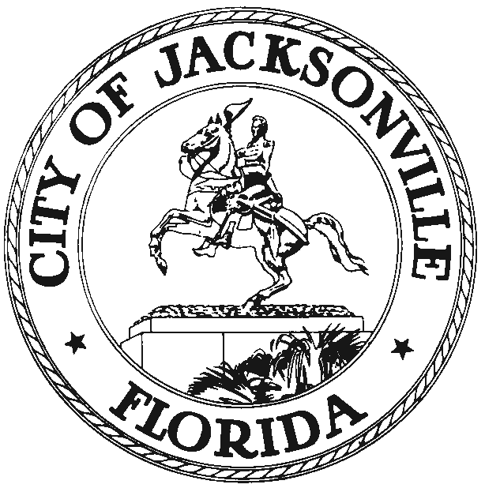

DUVAL COUNTY VALUE ADJUSTMENT BOARD
117 W. Duval Street, Suite 305
Jacksonville, FL 32202
Office (904) 255-5124
Fax (904) 630-0576

January 6, 2021
(5:00 pm)

Notice is hereby given that Jacksonville City Council Member Joyce Morgan, Chair of the 2020 Value Adjustment Board, sets the following meeting dates and times for the 2020 VAB year monthly meetings. Chairwoman Morgan will meet with the Value Adjustment Board Members on the dates listed below at 9:00 am in the Council Chambers, 1st Floor, City Hall at St. James, 117 West Duval Street, Jacksonville, Florida.

A quorum of the Board Members (3) will need to be present in-person but other members may attend utilizing Communications Media Technology (CMT). The meeting will discuss topics related to the background and charge of the Board and any other items noted on the meeting’s agenda or at the discretion of the Chair.

Board Members, City staff and the public may attend the meeting at the physical location- Council Chambers, but CDC guidelines will be adhered to due to COVID-19. A mandatory mask requirement is in place for all public buildings pursuant to the COJ Emergency Executive Proclamation 2020-005, as extended.

The public will be encouraged to share general comments by email or telephone. Public hearings and public participation are required by state statute for specific legislation. We will conduct these hearings as required by state law. CCMeeting01262021@coj.net is the designated email for general comments to be including as a part of this meeting. Please contact any member of the VAB Staff, at (904) 255-5124, for additional information or correspondence.

If a person decides to appeal any decision made by the Value Adjustment Board, with respect to any matter considered at such meeting or hearing, he or she will need a record of the proceedings, and that, for such purpose, he or she may need to ensure that a verbatim record of the proceedings is made, which record includes the testimony and evidence upon which the appeal is to be based.
VALUE ADJUSTMENT BOARD MEETING DATES AND TIMES:
Dates Times
Thursday, January 14, 2021 9:00 AM
Thursday, February 11, 2021 9:00 AM
Thursday, March 11, 2021 9:00 AM
Thursday, April 15, 2021 9:00 AM
Thursday, May 13, 2021 9:00 AM

MEETING TIME: 9:00 AM – 11:00 AM
Physical Location: Council Chambers
City Hall
117 W. Duval Street
Jacksonville, Florida 32202

(If attending virtually, please join the meeting by 8:50 AM)
Meeting ID: 958 6120 4658 Passcode: 456581

WAYS FOR THE PUBLIC TO ACCESS THE MEETING:

- Sign up for Zoom. Type - Zoom.US – with Chrome Internet Browser. Go to: JOIN A MEETING on Dashboard Information regarding the Zoom meeting ID and meeting password is listed below:
Meeting ID: 958 6120 4658 Passcode: 456581
(You can LISTEN to the meeting and VIEW the meeting this way.)
  - ALL PARTICPANTS WHO WANT TO PARTICIPATE IN LEGALLY REQUIRED PUBLIC PARTICIPATION MUST LOG IN WITH THEIR FULL NAME. (It would be helpful to identify bill to be addressed.) IE: Cheryl L. Brown 2020-0200

- Watch it on your computer. Streaming site (or COJ streaming site):
  - https://www.coj.net/city-council/city-council-meetings-online
- Joining a Zoom Meeting by phone:
- Dial: 1 646 558 8656 - Meeting ID: 958 6120 4658 Passcode: 456581
- Find your local number: https://zoom.us/u/a3xTSU8H6
- Attend the meeting in person at City Council Chambers, City Hall, 117 W. Duval Street, Jacksonville, Florida 32202.
- Look at the digital recording after the meeting located on the website under available archives- City Council click link: https://www.coj.net/city-council/city-council-meetings-online.

WAYS FOR THE PUBLIC TO PARTICIPATE IN LEGALLY REQUIRED PUBLIC HEARINGS OR PUBLIC PARTICIPATION VIRTUALLY THROUGH ZOOM:
- Refer to attached documents:
  - Council Member Attendance and Voting Through Virtual Technology
  - Council Process - Post Expiration of Governor’s Executive Order
- Legal Name must appear on Zoom to be recognized by the Chair.
- DO NOT state your residence/address as this is not required in this forum – only state County and Zip Code.
- Timeframe set by Chairman – No more than 3 minutes per speaker.
- The Timer will be viewable. Must be in “Gallery View” to see countdown; Sort those in meeting by going to “Participant” and typing in Timer.
- Chairman will “ONLY” call on speakers using the ELECTRONIC “RAISE HAND” feature located within the Zoom App. This feature is found- Click on “Participants” scroll to the bottom, click on “Raise Hand,” wait to be recognized. (Must have a Microphone, Video, and Speakers to participate with the function.)

WAYS FOR THE PUBLIC TO MAKE COMMENTS AT THE MEETING:
- You can email your comments to: CCMeeting01122021@coj.net
- For some meetings, you will be able to call in to make a comment on the phone or make a comment in person. Many meetings, especially informational ones, may not have public comment. It is at the discretion of the Committee Chair to allow public comment at Committee meetings.

INSTRUCTIONS: JOINING A MEETING BY DIAL-IN PHONE ONLY
- Dial numbers provided above. If you dial a toll number, your carrier rates will apply.
- You will be prompted to enter the Meeting ID – the Meeting ID: 958 6120 4658 Passcode: 456581
- If the meeting has not already started and join before host is not enabled, you will be prompted to press # to wait if you are participant.
- You will be prompted to enter your unique participant ID. This only applies if you have joined on the computer or mobile device or are a panelist in a webinar. Press # to skip.
- If you join by computer or mobile device later, you can enter the Participant ID to bind your phone and device session together and show your video when you speak on the phone.
- To enter your participant ID once you are in the meeting, enter #Participant ID# on your phone.

PHONE CONTROLS FOR DIAL-IN PHONE ONLY PARTICIPANTS
The following commands can be entered via phone tones using your phone's dial pad while in a Zoom meeting:
- *6 - Toggle mute/unmute (While this is a function that is available the mute and unmute function will be controlled by the Host not the participant. To speak, the participant must use the *9 function to be recognized.)
- *9 - Raise hand (Electronic Zoom feature that “Must” be used to be recognized by the Chairman to Speak)
- Refer to attached documents:
- Council Member Attendance and Voting Through Virtual Technology
- Council Process - Post Expiration of Governor’s Executive Order
- Legal Name must appear on Zoom to be recognized by the Chair.
- DO NOT state your residence address as this is not required in this forum –
  - only state your County and Zip Code
- Timeframe set by Chairman – No more than 3 minutes per speaker.
- Phone in participants will be informed of remaining time.
- Chairman will “ONLY” recognize or call on speakers using the ELECTRONIC “RAISE HAND” feature located within the Zoom App *9, wait to be recognized. (Must have a Microphone and Speakers on phone to participate with the function.)

It is important that you use one of the above remote ways to access the meeting; the Mayor has imposed rules on social distancing because of the COVID-19 Virus. If you have any problems or questions about gaining access to the meeting, please call 904 255 5193 and leave your name, number, and a brief message.

JM/hp

XC: Council Members/Staff Steve Cassada, Systems Information
Dr. Cheryl L Brown, Council Secretary Melanie Wilkes, Systems Information
Katrina Fisher, Office of Council Director Yvonne Mitchell, Research Assistant
Sharonda Davis, Sr. Manager Leg. Svcs. Peggy Sidman, Deputy General Counsel
Paige Johnston, Assistant General Counsel Shannon Eller, Office of General Counsel
Jason Gabriel, General Counsel Jeff Clements, Chief of Research
Kristi C. Sikes, Chief of Administration CITYC@COJ.NET
Electronic Notice Kiosk- 1st Floor City Hall Public Notice System-Council Webpage
Kim Taylor, Council Auditor Philp Peterson, Asst. Council Auditor
Carla Miller, Exec. Director- Ethics Commission Kirby Oberdorfer, Ethics Commission
Carol Owens, City Council Andrea Hartley-Myers, Ethics
Mary Staffopoulos, Office of General Counsel File Copy
Media and Media Box

