TASK FORCE ON DEMOLITION BY NEGLECT

Jacksonville Historic Preservation Commission

City of Jacksonville

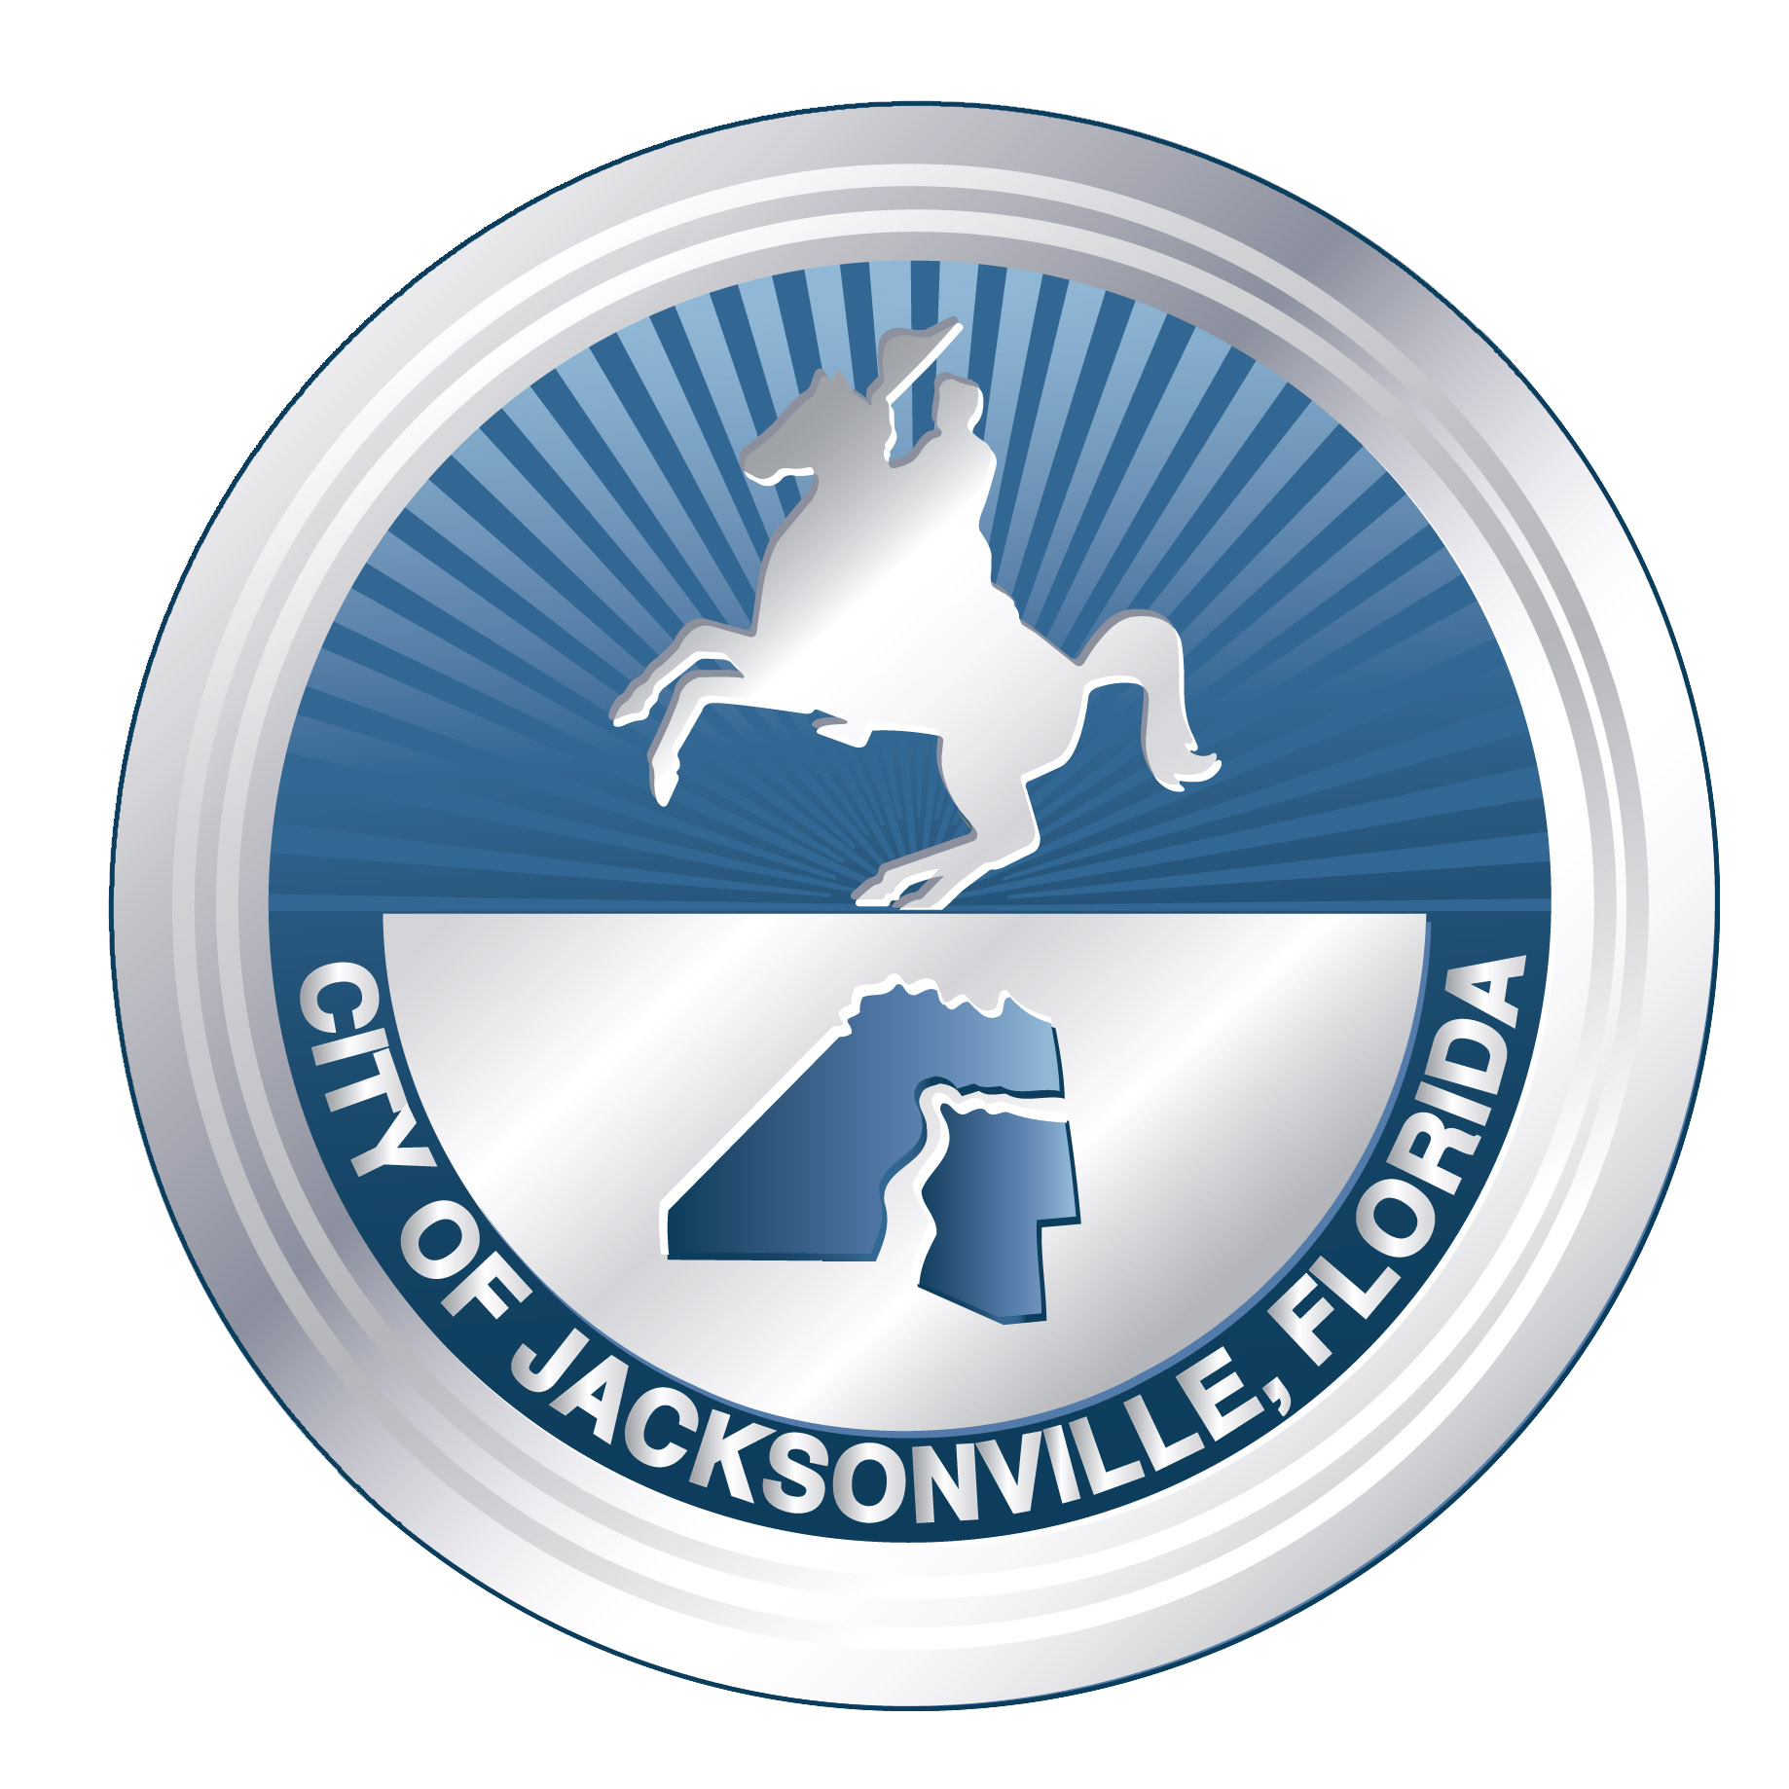

FINAL REPORT

March 13, 2025

*“The presence of historic properties as working and productive assets in our communities gives us an important link between the past and present, and reminds us of what we were, who we are, and where we hope to be”*

- Ronald Reagan, Historic Preservation Awards, 1988.

**Introduction -**

City Council approved ordinance 90-275-250 in 1990 to establish the Jacksonville Historic Preservation Commission (JHPC), tasked with overseeing historic preservation actions for the City of Jacksonville. Chapter 307, ordinance code, recognizes that historic preservation is “...required in the interest of the health, prosperity, safety, welfare and economic well-being of the people” and specifies the importance of safeguarding and promoting the role of historic districts and historic landmarks to strengthen Jacksonville’s cultural, aesthetic, and economic standing. After years of seeing the preventable destruction of historic assets at JHPC meetings, and hearing concerns from both the public and community organizations, the Task Force on Demolition by Neglect was established by the JHPC on September 10, 2024 to examine the phenomenon and recommend solutions.

Demolition by Neglect can be described as the abandonment of a building or structure by the owner resulting in such a state of deterioration that its self-destruction is inevitable, or where demolition of the building or structure to remove a safety hazard is a likely result. Demolition by Neglect can be the result of benign indifference or a deliberate strategy to circumvent historic preservation restrictions against demolition. Demolition by Neglect has been described as a “loophole” in preservation policy. Regardless of the owner's motivation, the result is the same: the loss of finite historic, cultural, and aesthetic resources that cannot be authentically replaced. Demolition by Neglect affects not just the neglected structure, but also the surrounding area, and can start a contagious cycle of decay and disinvestment. The practice is especially problematic when it impacts historic landmarks and contributing structures within historic districts, which have been found worthy of preservation for future generations. Since 2021, when the city began tracking, at least 52 historic demolitions have been approved.

Notably, Demolition by Neglect also reduces the housing stock available in our community, adding to the local housing deficit. The loss is particularly relevant to the historic districts of Jacksonville, which have a higher capacity for residential density compared to other areas of the city. While neglect comes with a cost, the economic ROI of historic preservation has been widely shown to benefit tax revenue, job creation, and revitalization. Fortunately, the City of Jacksonville has existing, yet underutilized ordinance and options that can quickly affect the issue. With process improvements and small investments, Jacksonville can emerge as a national leader in heritage conservation, historic preservation, and responsive Demolition by Neglect policy.

**Summary Findings -**

* Demolition by Neglect is a pressing issue that municipalities around the country struggle with to varying degrees and is not a unique concern for Jacksonville’s locally designated historic properties.
* Financial penalties such as fines/liens on historic properties are often inadequate to address Demolition by Neglect, both locally and elsewhere. Fines/liens are often ignored by the property owner and eventually reduced by the municipality, making them ineffective. For example, $196,440,890 in fines have been issued to properties within local historic districts since 1998, while only $431,719 have been paid during that time period - that’s 0.22%.
* Elements of successful strategies in other municipalities to address Demolition by Neglect include:
* Proactive actions such as regular coordination between relevant city departments
* Criteria to determine when a property is threatened by Demolition by Neglect
* Strategic use of foreclosure by the municipality to prevent and/or deter Demolition by Neglect
* Utilization of a non-profit entity to receive a previously foreclosed upon historic property as an alternative to Demolition by Neglect
* Community engagement to educate and support the value of historic preservation
* The City of Jacksonville has existing ordinances that, if utilized, would significantly reduce the occurrence and negative impact of Demolition by Neglect.
* Recommendations should be **~~limited to~~** **focused on** properties within the locally designated historic districts (currently Riverside, Avondale, St. Johns Quarter, Springfield) and locally designated landmarks.

**Priority Recommendations -**

(1) COJ Municipal Code Compliance Division (MCCD) will create and maintain a list of properties which have fines/liens related to maintenance deficiencies, safety, and blight, and which are located within a locally designated historic district and/or a locally designated historic landmark. The list shall include the real estate number, address, type of structure, category of historic designation, description of violation, length of time the property has been in violation, total fines/liens, the status of the violation being resolved, ability to be occupied, or other information. This will be an important tool to help proactively identify properties at higher risk for Demolition by Neglect and coordinate an appropriate response.

(2) COJ Historic Preservation Section, Historic Preservation Commission (HPC), and MCCD will create objective criteria to determine when a property within a locally designated historic district and/or a locally designated historic landmark meets the threshold for being in danger of Demolition by Neglect, and a develop a standardized process to engage the property owner. A scored matrix or similar tool designated by HPC will be used to assist with this process, and be implemented no later than July 31, 2025.

(3) MCCD, Historic Preservation Section, Building Inspection Division, and a HPC chair or their designee, will meet to review the list of properties within locally designated historic districts and/or locally designated landmarks which have fines/liens to coordinate an appropriate plan to address properties most at-risk to Demolition by Neglect. Meetings shall occur monthly for the first three months, then as needed. Outcomes of these meetings will be shared at the subsequent HPC meeting.

(4) COJ will exercise their authority to foreclose on properties that have outstanding liens to strategically foreclose on properties within locally designated historic districts, and locally designated landmarks, which meet the criteria of being endangered by Demolition by Neglect, to prevent their demolition and/or facilitate their renovation/redevelopment. Not since 2014 has COJ foreclosed on a locally designated historic property to prevent its demise - the Bostwick Building, now the Cowford Chophouse.

(5) COJ will partner with the Jacksonville Community Land Trust (JCLT) or other organizations to dispose of foreclosed properties within locally designated historic districts, and locally designated landmarks, which are not sold at auction. The purpose of such a partnership would be for such organizations to either take ownership of a property with the intent to renovate or work with the COJ to identify appropriate redevelopment partners.

**~~Short term~~ Medium Term recommendations (< 1 year) –**

**The following recommendations will be initiated within one year**

(1) COJ will create a Special Revenue and Trust Account, the “Code Enforcement Historic Special Revenue Fund”, into which funds derived from the collection of civil penalties issued within the locally designated historic districts pursuant to Chapter 518 and Chapter 656 and the settlement of fines imposed and levied within the historic districts by Chapter 91. These funds will be used as a revolving loan designated to pay for the exterior repair/renovation of homes or buildings owned by property owners at or below 80% of area median income, located within the locally designated historic districts.

(2) COJ, through the Finance Department and Tax Collectors office, will create streamlined processes for collections dedicated to specialized funding accounts, with funding reported annually to the City Council.

(3) COJ will establish a process to add nuisance and demolition liens to the non-ad valorem tax assessment rolls. This will close loopholes that allow negligent property owners to reduce their liens and will require timely payment for property neglect. Since 1998, $1,121,360.86 in liens have been placed on properties within the locally designated historic districts, while only $66,736.52 have been collected - that’s 5.95%. Currently, the total lien interest accumulated is more than the original liens themselves.

(4) COJ will remove the Florida Association of Code Enforcement (FACE) certification requirement within MCCD and create internal training modules focused on Florida Statutes and local municipal ordinances, including historic property inspections and strategies to prevent Demolition by Neglect. This cost-effective adjustment will improve service and outcomes.

(5) COJ Historic Preservation Section, MCCD, and HPC will coordinate to provide **ongoing** guidance to community organizations/members of the community on how they may assist with preventing Demolition by Neglect through engagement and education. Information will include subjects such as affirmative maintenance, economic hardship resources, mothballing, navigating code compliance, checking status of violations, etc.

(6) COJ Historic Preservation Section and HPC will coordinate with community organizations to proactively identify historic assets and candidates for locally designated historic landmarks, as described in Section 76.103. - Powers and duties (a)(2). By identifying historic assets prior to deterioration, these assets can be better protected against Demolition by Neglect.

(7) COJ will send an annual notification to property owners of properties within locally designated historic districts and locally designated landmarks, explaining the unique status of their property, the responsibility of the owners to maintain, the role of the Historic Preservation Section and HPC, and other related resources. A frequent justification by applicants who seek demolition of historic properties is a lack of awareness that leads to the deterioration of the property, and this will address that issue.

(8) COJ will fund the Restore Endangered Historic Adaptable Buildings (REHAB) program on an annual basis of at least $500,000. This program provides vital financial assistance to income producing and/or non-profit historic properties outside of Downtown Jacksonville which have significant deterioration and are highly vulnerable to further decline and/or Demolition by Neglect. The program’s inaugural application period had overwhelming interest, indicating great need.

(10) A Certification of Appropriateness (COA) application~~s~~ for the demolition of a contributing property within a locally designated historic district, or locally designated historic landmark, will require a report from a structural engineer with a demonstrated knowledge and expertise in remediation of historic resources, presenting both the identified problems and possible solutions in detail, including visual evidence.

(11) Historic Preservation Section and MCCD will review potential improvements to the mothball program, established in Section 307.301 and allocate permanent resources to the maintenance and monitoring of eligible properties.

**~~Medium~~ Long term recommendations (< 2 years) -**

**The following recommendations will be initiated within two years**

(1) MCCD will conduct inspection projects in locally designated historic districts bi-annually, to enforce the preservation policies of Chapter 307 and address issues of nuisance, blight, and poorly maintained properties.

(2) COJ will fund neighborhood historic surveys on an annual basis, as it has done previously, to proactively identify historic assets. By identifying historic assets prior to deterioration, they can be better protected against Demolition by Neglect and fully realize their potential value to the community.

(3) Historic Preservation Section will coordinate with Northeast Florida Association of REALTORS (NEFAR) and Northeast Florida Builders Association (NEFBA) and other professional real estate organizations to educate professionals and their clients about responsibilities and resources associated with owning locally designated historic properties.

(4) COJ will fund additional personnel in the Historic Preservation Section and MCCD to fulfill their roles in preventing Demolition by Neglect, addressing blight conditions, and supporting historic preservation. The Historic Preservation Section is responsible for overseeing the care and accommodation of almost 6,000 existing unique structures in the locally designated historic districts alone, along with the public spaces and streetscapes within these areas, local landmarks, contributing structures within national historic districts, research, etc. Staff documented a roughly 20% increase in Certificate of Appropriateness applications from 2023 to 2024 (1,494 to 1,783) and with the popularity of these areas growing, and more properties around Jacksonville becoming eligible for historic status designation, demand for Historic Preservation Section services is only increasing. Similarly, MCCD has roughly the same number of enforcement agents as it did in 2013, while Jacksonville has seen exponential growth during that same time. **For example, the Jacksonville population in 2013 was 843,960; in 2025, the estimated population is 1,000,485 – this is a roughly 20% increase.**

**Closing -**

From Mandarin to Durkeeville, Arlington to San Marco, LaVilla to the Beaches, Jacksonville is blessed with fantastic history and culture worth protecting. A finite number of buildings, homes, sites, and structures remain that tie our storied past to our quickly-changing present. Dozens of recognized historic structures in Jacksonville have been lost to demolition in recent years, the majority of which were simply not appropriately maintained or prioritized by their owners. By acting on the recommendations listed in this report, the City of Jacksonville can fulfill its responsibility to the public as described in Chapter 307, position itself as a leader in preservation strategy, and reap the subsequent economic rewards. By doing so, we will ensure that current and future generations of locals and visitors alike can find inspiration in Jacksonville’s past, while enjoying the fruits of its growth.

**Methodology and Acknowledgements -**   
  
The Task Force held public meetings on 10/08/24, 10/29/24, 11/12/24, 11/29/24, 12/09/24, 1/14/25, 1/28/25, 2/13/25, 2/27/25, and 3/13/25.  
  
Municipalities in Florida examined during the course of the Task Force include Belleair, Bonita Springs, Broward County, Delray Beach, Eatonville, Eustis, Fort Myers Beach, Gainesville, Gulfport, Highland County, Hillsborough County, Homestead, Jupiter, Lee County, Miami Beach, Miami-Dade County, Monroe County, Mount Dora, New Smyrna Beach, Oakland Park, Ocala, Orlando, Palatka, Pinellas County, St. Augustine, St. Petersburg, Tampa.

Municipalities in other states examined during the course of the Task Force include Charleston, SC, New Orleans, LA, New York, NY, Philadelphia, PA, San Diego, CA, San Antonio, TX, Santa Fe, NM, Savannah, GA, Topeka, KS, Washington D.C.  
  
Individuals who provided input or assistance in the development of this report include Ginny Myrick, Jessie Spradley, Jack Shad, Robert Jordan, Crissie Cudd, Peter King, Alan Bliss, Ennis Davis, Robin Pfalzgraf, Cyndy Trimmer, Alex Sifakis, Susan Grandin, Adrienne Burke, Mike Field, Kay Ehas, Travis Williams, Sondra Fetner, Ann-Marie Knight, Mari Kuraishi, Patrick Krechowski, Laureen Husband, Eleanor Burke.  
  
City of Jacksonville staff who provided input and/or assistance in the development of this report include:  
  
Arimus Wells, City Planner Supervisor, Historic Preservation Section  
Brittany Figueroa, City Planner II  
Caleb Arsenault, City Planner I  
Martin Kennelly, Historic Preservation Code Inspector  
Thomas Register, Chief of Municipal Code Compliance Division  
Robert Ownby, Neighborhoods Property Administrator  
Jason Teal, Deputy General Counsel  
Carla Lopera, Assistant General Counsel  
  
The Taskforce on Demolition by Neglect and invited subject matter experts include:  
  
Bill Hoff Jr, Task Force Chair, JHPC Secretary  
Julia Epstein, Task Force Vice Chair, JHPC Commissioner  
Becky Morgan, Task Force Member, JHPC Commissioner  
Michael Montoya, Task Force Member, JHPC Chair  
Shannon Blankinship, Executive Director, Riverside Avondale Preservation  
Michael Haskins, Executive Director, Springfield Preservation & Revitalization