INTRA-GOVERNMENTAL SERVICES

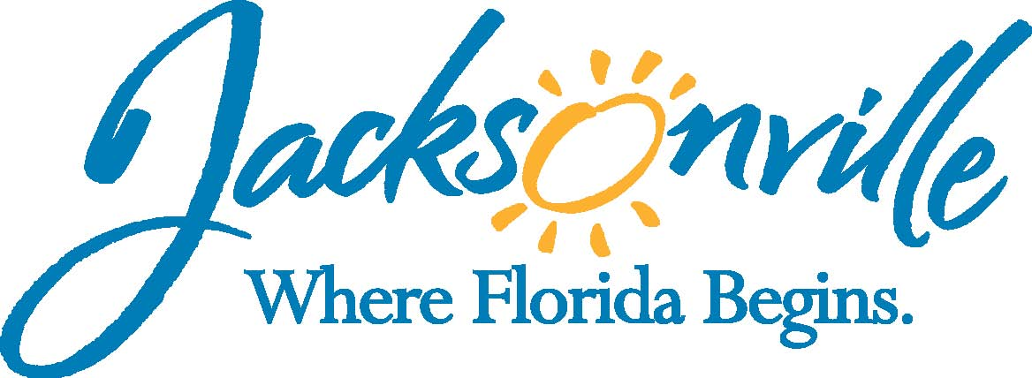

City of Jacksonville
Office Grants & Contracts Compliance

PUBLIC SERVICE GRANT (PSG) COUNCIL

MEETING RULES COMMITTEE

Ed Ball Building, 8th Floor, Room 851

Wednesday, January 25, 2016 1:30 p.m.
PSG Chair: Dr. Jerry Fliger

Committee Meeting Attendance
E | Roshanda Jackson | X | Darrell Gardner (not confirmed)
X | Dr. Jerry Fliger | X | Tameka Holly
E | Dr. Stephen Baker (not confirmed) | X | Deborah Johnson
E | Bob Baldwin | E | Dr. Sandy Robinson
E | Carol Brock | E | Dr. Marcie Turner
E | Lara Deittrich | E | Chris Warren
X | Dr. Georgette Dumont
Quorum Present: YES
Staff: John Snyder
Damian Cook
Sandra Stockwell, OGC

- Welcome & Introduction of PSG Council Members – Dr. Fliger
Dr. Fliger called the meeting to order at 1:33 PM and members introduced themselves.

- Old Business – Mr. Cook
Dr. Fliger opened the meeting by discussing the need to establish how to settle the issue of two PSG Applications that receive the same score. The committee discussed the issue of a tie and to determine that only whole numbers will be used to determine a tie there will be no need to carry out an average to any decimal places. Therefore, an agency whose scores an 88.9 and another agency that scores an 88.0 will be considered a tie. In the case of a tie the Grant Administer will be instructed to rank those agencies according to their average score on the different sections of the score sheet in the following order; section 5, section 4, section 7, section 3, section 1, section 8, section 6, and section 2.

This ranking was posted on the projector for those in attendance and Dr. Fliger then asked for public comment.

Rena Coughlin with the Non-Profit Center asked for an example of how this will work. Dr. Fliger went over an example of how this process would work.

Judy Bradshaw with Learn To Read asked if those scores that were discarded in the final average would those sections be used to determine the average. Dr. Fliger indicated that this tie would occur after the final average, so those scores would not be used to break a tie.

Collean Readon with Salvation Army asked about included outlier scores. Mr. Cook explained that this was determined by City Council.

Dr. Dumont motion for approval and Ms. Holly seconded the motion-passed unanimously.

Dr. Fliger asked Mr. Cook to discuss how it will handle the issue concerning a non-profit who is exempt from filling an IRS Tax Statement (IRS Form 990) and solicitation permits. Mr. Cook explained that after meeting with OGC it was determined that we would asked for an audit, if an agency did not have an audit we would ask them to fill-out a form which is similar to the State’s financial form for an agency who is seeking an exemption for a solicitation permit. Mr. Cook also spoke about adding this information to the scoring sheet (section 3).

- Review of Ordinance 118.804 – Mr. Cook
Mr. Cook went over section 118.804 and discussed the handout that was provided to members for them to review concerning the Procurement Process.

- Review of Procurement Information – Mr. Cook
See above

- Open Discussion
Rena Coughlin with the Non-profit Center offered to have the next Rules Committee meeting at their location to discuss this option and possibility of using this option for additional funding.

- Public Comment
None

- Adjourn
Meeting was adjourned at 3:00 p.m.

Next Meeting Date TBA
Recorder: Tiffanie Wilson
Completed – 1/30/2017
An audio recording is available upon request

