INTRA-GOVERNMENTAL SERVICES

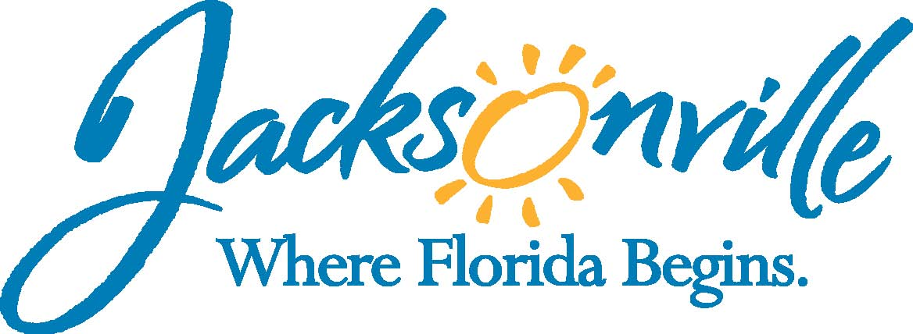

City of Jacksonville
Office Grants & Contracts Compliance
Public Service Grant Council

Ed Ball Building, 8th Floor, Room 851

Wednesday, December 14, 2016 11:00 a.m.
PSG Chair: Roshanda Jackson

Public Service Grant Council Member Attendance
X | Roshanda Jackson, Chair | X | Deborah Johnson
E | Dr. Jerry Fliger, Vice-Chair | X | Tameka Holly
E | Iris Young | X | Lara Diettrich
X | Carol Brock | E | Chris Warren
X | Dr. Margie Turner | X | Bob Baldwin
X | Dr. Georgette Dumont
Quorum Present: YES
Staff: John Snyder
Damian Cook
Sandra Stockwell
Council Liaison:
C/M Joyce Morgan

- Welcome & Introduction of PSG Council Members–Ms. Jackson
New member Dr. Sandy Robinson (FSCJ)

- Public Service Grant Council Meeting Minutes Approval– Ms. Jackson
11/09/16

- Priority Population Sub-Committee Update-Ms. Johnson
Ms. Johnson will provide an update. The final report is due February 8, 2017. Recap of the previous meeting was given: the ordinance was re-read, Mr. Snyder provided a historical overview of how the priority populations have been determined in the past, and agencies which could help determine the priority population’s needs were identified.

- Budget Sub-Committee Update-Ms. Holly
Ms. Holly (newly elected chair) will provide update. The final report is due on March 8, 2017. The previous meeting was on December 12, 2017. The budget is expected to remain flat. This must be taken into consideration when understanding the budgetary needs of the priority populations. Methods for making the budget more accessible to the agencies were discussed at the sub-meeting. The budget changes, moving forward, are more focused on year 2018.

- Rules Sub-Committee Update-Dr. Fliger (excused, update given by Ms. Holly)
The meeting was held December 13, 2016. Evaluation measures were discussed in regards to the agencies’ performances the previous year and how that will affect agency applications and funding amounts. The committee discussed ways religious organizations can be required to provide financial records/documentation so the PSG can utilize the information when considering agency applications in the absence of 990s. Discussed was the measure/weight given to the “impact” category of the evaluation and it was determined that more deference to an agency’s impact on the community’s goals should be given in the scoring process. Discussed was how to resolve the issue of a “tie” amongst two or more agencies. Several possible methods were discussed.

- Discussion/Comments/Requests/Recommendations-Ms. Jackson
It was recommended that the smaller organizations should be given just as much attention and consideration as the larger organizations because they do just as well, if not better, than the larger organizations at fulfilling their missions. Comments and recommendations from the sub-committees will be accepted and shared with the chair. A recommendation was given to remember the “sunshine” laws and to be mindful of the rules pertaining to ensuring the public has access to information shared between members. Comments submitted should be read aloud in the meeting so the public will have access to meeting information. In the Rules committee, Dr. Fliger wanted the committee to look at how unused funds can be used to benefit smaller agencies.

- Public Comments
No comments.

- Adjourned
Adjourned at 11:24 a.m.

Next Meeting Date
January 11th, 2017
Recorder: Tiffanie Wilson
Completed – 12/21/2016
An audio recording is available upon request

