INTRA-GOVERNMENTAL SERVICES

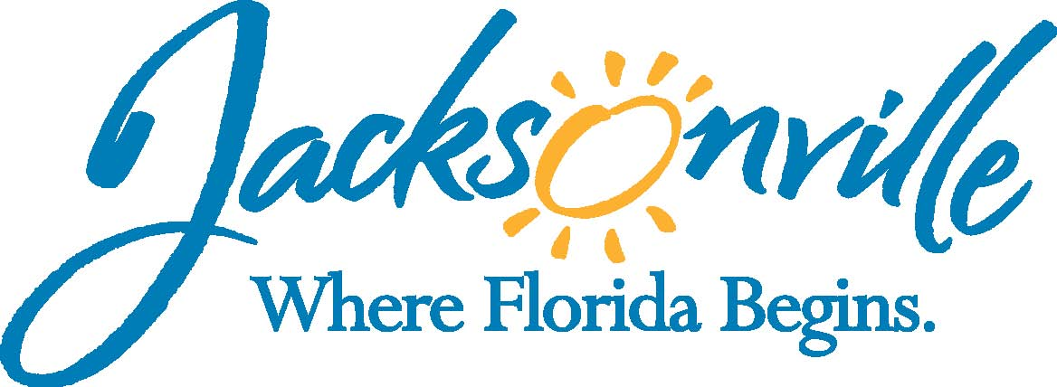

City of Jacksonville
Office Grants & Contracts Compliance
Public Service Grant Council
Budget Sub-Committee Meeting

Ed Ball Building, 8th Floor, Room 851

Thursday, December 8, 2016 3:00 p.m.
PSG Chair: Roshanda Jackson

Public Service Grant Council Member Attendance
X | Roshanda Jackson, Chair | X | Deborah Johnson
X | Dr. Jerry Fliger, Vice-Chair | X | Tameka Holly
Quorum Present: YES
Staff: John Snyder
Damian Cook

- Welcome & Introduction of PSG Council Sub-Committee Members – Ms. Jackson

- Election of Sub-Committee Chair- Ms. Jackson
Dr. Dumont could not chair the budget sub-committee. Call for a vote on Sub-Committee Chair. Dr. Fliger moved for Ms. Holly to be the chair, Jackson seconded the motion. There was no opposition to the appointment. Ms. Holly is the budget sub-committee chair.

- Reading of Ordinance Section 118.802 (Annual Lump Sum Request)-Mr. Snyder
Mr. Snyder read the ordinance and a discussion followed regarding the purpose and requirements of the budget sub-committee.

- Overview of Current Budget and Anticipated Revenue & Issues- Mr. Cook
PSG has to review, vote, and approve the budget to submit to the Mayor’s Office by March 1st. The request as well as how the committee estimated the requested amount is needed to submit to the mayor’s office.
Goal is to have the budget done by PSG committee February 2017 meeting so if there are discussions needed, they can be held before March 2017.
Budgets are not expected to increase. Revenue and expenditures will both increase. Pension is a large part of the budget expenditures.
Per the Mayor’s Budget Reform, a pension has to close (corrections, police and fire, or general employees). If one of the pensions does not close, access to this revenue type will be terminated.
General Revenue from FY15-FY16 increased $44.6M; cost increased by 8.3%.
Recommendation for the budget committee, take into consideration the needs of the community and the realistic budget expectations considering the changes to the pension and budget goals stemming from the mayor.
Prior to the next meeting, the agencies should be given questions that would be asked by the committee members during the meeting. Agencies are going to be given guidance by Ms. Lockheart as to the information committee members will find useful.

- Historical overview of the Budget Recommendation–Mr. Snyder
The budget was based on the previous year or what the agency received the previous year. Sub-committee must correlate the budget requests to reaching goals in the priority populations.

- Discussion
Joint meeting of the two committees will be conducted to ascertain what goals the budget committee should be moving toward. Both committees should be involved so all committee members can have the information necessary to make informed decisions. Ms. Lockheart was tasked with coordinating with the agencies and committees to gain recommendations for the budget and resource allocation and metrics measurements. It was suggested that each agency present for approximately an hour.
The January meeting for the Priority Population sub-committee is to precede the PSG meeting. The PSG should generate a preliminary budget.
Suggestions were given as to how PSG can make a difference and meets its goals in conjunction with the agencies. It was suggested PSG take the initiative to ask for a budget increase and be more creative in how to make the PSG more effective.

- Public Comments
No comments.

- Adjourned
Meeting adjourned at 3:50 p.m.

Next Meeting Date
January 11th, 2017
Recorder: Tiffanie Wilson
Completed – 12/13/2016
An audio recording is available upon request

