INTRA-GOVERNMENTAL SERVICES

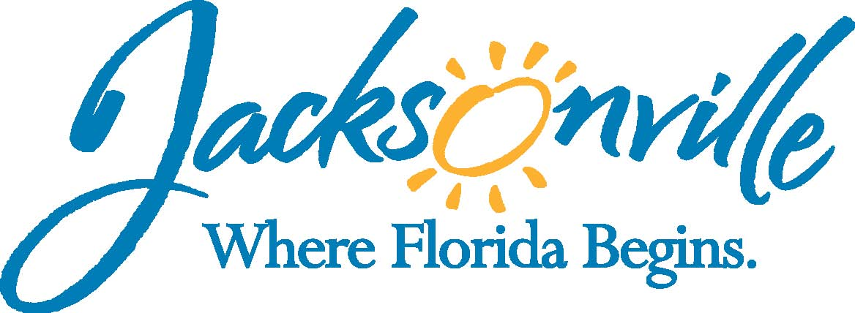

City of Jacksonville
Office Grants & Contracts Compliance
Public Service Grant Council

Priority Population Sub-Committee Meeting

Ed Ball Building, 8th Floor, Room 851

Monday, December 5, 2016 3:00 p.m.
PSG Chair: Roshanda Jackson

Priority Population Sub-Committee Meeting Attendance
X | Roshanda Jackson | X | Deborah Johnson
X | Dr. Marcie Turner | X | Chris Warren
X | Bob Baldwin
Quorum Present: YES
Staff: John Snyder
Damian Cook

- Welcome & Introduction of PSG Council Sub-Committee Members–Ms. Jackson
The Priority Population Sub-Committee Meeting (hereafter “meeting”) was called to order by Ms. Jackson, Chair, at 3:05 p.m. The meeting members and staff introduced themselves.

- Reading of Ordinance 118.804-Priority Populations or Needs-Mr. Synder
Committee members read the ordinance to refresh their recollection and understanding of the content.
Ms. Jackson and Mr. Synder were asked if they had comments on the ordinance. Mr. Synder commented on the information provided and the process followed for when information is requested.
Committee member offered the idea of compiling a list of entities that would need to be reviewed for the analysis and studies in order to ensure organizations are not left without consideration/application when they need it.
Dawn Lockheart (Director of Strategic Partnerships, Mayor’s Office) is doing a “gap analysis” on what the different organizations are focused on. She offered to leverage her position in the Mayor’s office and be a liaison for information between organizations like United Way and the committee in order to prevent the organizations from having to come to the meetings formally. Ms. Lockheart would represent the organizations in the meetings. She currently has no timeline for completion of the gap analysis. She answered questions about her role in the Mayor’s Office (which is to “connect the dots”).

- Overview of mayor’s priorities including any identified challenges-Ms. Lockheart
Priorities of the Mayor: Neighborhoods, Youth, Health, Wellness, etc.
What challenges are the disconnects between actors in the initiatives in the mayor’s priority list. Ms. Lockheart suggested private donors partner to make a much more intentional impact. Donors should be invited to meetings to gain understanding that will complement the city’s investments.

- Historical overview of the priority populations–Mr. Snyder
Mr. Synder presented the legal spreadsheet that is used to track the amount of funds requested and awarded per year. The priority populations are also tracked. Historically, there was no set methods of data collection to determine what funding was needed as the funding requests are submitted by the requesting organizations.

- Identification of studies currently available for review-Mr. Snyder
JCCI-Community Snap Shot, NEFL Health Planning Council Needs-Assessments, HUD, Homeless Counts, and Jessie Ball DuPont

- Identification of agencies/organizations to be invited to make presentations to our subcommittee-Mr. Snyder/Mr. Cook
Jessie Ball DuPont, United Way, JCCI (maybe), and Community Foundations were mentioned.

- Open Discussion
Strategic partnerships with defined outcomes will help better allocate and manage resources to execute the large-scale goals. Suggestions on what the next step the sub-committee should be. The best investment would be to converse with the other organizations responsible for community planning. State and city priorities change, there needs to be a way to identify when priorities change at higher levels. A brief overview of the grants/organizations that have funds allocated to them currently.
Members brought up the concern for knowing what other funding the organizations are receiving from the city. The recommendation was made to create a system for gathering and storing that information.
Damien gave oversight and clarification of how to advance the priority population grants process and timeline.
The most immediate action is to maintain the current process for the grant’s process. The strategic alterations are better suited for long-term application, when more information is available from the agencies to ascertain the needs of the agencies.
A report should be given to the full committee as a means of showing efforts and moving forward. But that the timeline may not permit any further action because the depth in which it takes to come up with an all-encompassing solution is long.
Meetings with the agencies are to be scheduled to seek information relevant to their needs and budget goals.
Dawn Lockheart to provide a list of agencies to meet with to gather the budget and community needed information.

- Public Comments
There were no public comments.

- Adjourn
Meeting was adjourned at 4:30 p.m.

Next Meeting Date 1/11/2017 at 1-4:30 p.m.
Recorder: Tiffanie Wilson
Completed – 12/12/2016
An audio recording is available upon request

