INTRA-GOVERNMENTAL SERVICES

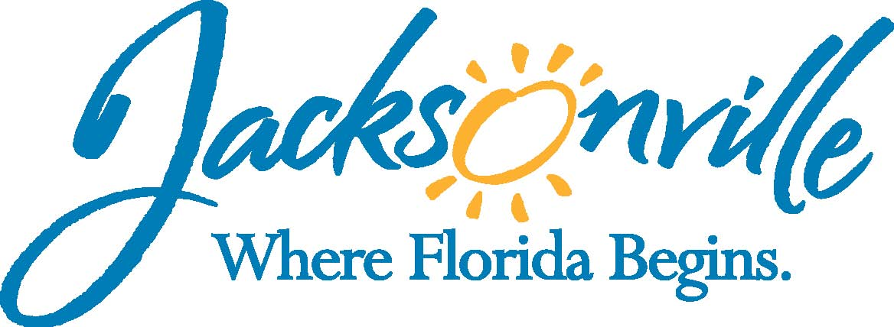

City of Jacksonville
Office Grants & Contracts Compliance
Public Service Grant Council

Ed Ball Building, 8th Floor, Room 851

Wednesday, November 09, 2016 11:00 a.m.
PSG Vice-Chair: Dr. Jerry Fliger

Public Service Grant Council Member Attendance
E | Roshanda Jackson, Chair | X | Deborah Johnson
X | Dr. Jerry Fliger, Vice-Chair | X | Chris Warren
X | Iris Young | E | Bob Baldwin
E | Carol Brock | E | Tameka Holly
X | Dr. Marcie Turner | X | Lara Diettrich
X | Dr. Georgette Dumont
Quorum Present: YES
Staff: John Snyder
Damian Cook
Lawsikia Hodges, OGC
Council Liaison: C/A Darren Mason (C/M Joyce Morgan)
C/VP Crescimbeni

- Welcome & Introduction of PSG Council Members – Ms. Jackson
The Public Service Grant Council (hereinafter “PSGC”) meeting was called to order by Dr. Jerry Fliger, Vice-Chair, at 11:10 a.m. The PSGC members and staff introduced themselves.

- Public Service Grant Council Meeting Minutes Approval– Ms. Jackson
Dr. Dumont moved approval of the minutes from October 31, 2016. Ms. Johnson seconded the motion. The motion passed unanimously.

- Set date and time of sub-committee meetings-Dr. Fliger
Dr. Fliger instructed Mr. Snyder to send out an e-mail asked for the members and chairs of each sub-committee to come up with dates. He stated that these dates should be set by the December PSG Council meeting. (completed 12/16)

- Ethics, public records and open meetings laws for PSG Council members- Ms. Hodges
Ms. Hodges went over the Sunshine Law, Public Records, & Ethics handout (attached in the office file)

- Priority Population recommendations- Mr. Snyder
Mr. Snyder went over the packet of material (see file) to include the following;
- PSGC Member contact information used for public record
- Highlights of New Chapter 80 7 Chapter 118 part 8
- Staff PSG Application Requirements Check List
- PSG Application
- PSG Scoring Sheet
- PSG Timeline(s)
Mr. Snyder detailed the requirements of chapter 118.804 specifically mentioning the due date for the filing of legislation to City Council (March 1st). He added that more information will be discussed during sub-committee meeting. Dr. Fliger stated that the sub-committee must have their recommendation to the full PSGC by the February meeting.

Mr. Snyder also spoke about the due date for the recommendation on a budget to MBRC (April 1st). Dr. Fliger stated that the Budget Sub-Committee then should have their recommendation to the full PSGC by the March meeting.

- Eligibility qualifications for Public Service Grants-Mr. Snyder
Mr. Snyder went over the requirements and the Staff Check List Sheet indicating that this is all objective information either the agency has the information or not. He also talked about how now with the electronic filling of the application they are not allow to upload their application without this information and all he does is verify that it is correct and up to date.

- Public Service Grant application requirements- Mr. Snyder
Mr. Snyder went over parts of the application talking about the requirements in the ordinance and how again an agency is not allowed to submit an application without the required parts of the application.

Dr. Fliger stated that any comments regarding the PSG Application Process and Scoring should be handled by the Rules Sub-Committee and they will come back with recommendations.

Mr. Cook spoke about the differences between parts of the application that are objective and subjective and that now the check list, courteous review, and the on-line application seem to work very well.

- Review, scoring and evaluation of Public Service Grant applications- Mr. Cook
Mr. Cook talked about the past application scoring and how this has changed and that now the scoring is more holistic looking a list of indictors from the application to various item on the Reviewer Comment Form. Mr. Cook briefly summarized this part of the ordinance focusing on items; #1, #3, & #8 from the Reviewer Comment Form.

Dr. Fliger indicated that he would like to discuss the norming aspects of this training at the June training so everything will be fresh in everyone’s mind before the start of the scoring. He wants to make sure that we have actual examples to use from different agencies.

Ms. Diettrich discuss that her conversation with Council Member Crescimbeni and how now she has a better understanding of the cross-referencing among various parts of the application to the scoring form.

- Limitations on funding allocations-Mr. Cook
Mr. Cook spoke about the $150,000 cap per application and the importance of using tax returns to verify agencies annual revenue.

- Opportunities for Exploration/Enhancement-Mr. Cook
Mr. Cook talked about a number of issues such as ties, the appeals process, the PSG Budget Request, Priority Population or needs, as well as the option for using the RFP process.

Dr. Fliger indicated that these are all issue that his Rules Sub-Committee will address.

Dr. Dumont pointed out the for non-profits tax returns are their 990’s, so what other forms are we going to look at to determine revenue since churches are exempt from filling 990’s or Solicitation Permits. Mr. Cook indicated that annual statement, budget, or audit would be something, but he will leave that decision up to City Council and OGC.

- Open Discussion
C/VP Crescimbeni spoke about how in the past he would get calls regarding the PSG and that this year he did not receive any calls. He spoke about how he saw two issues with PSG. The first was the process and that now the process seems to be working. The second issue was always funding and that now that the process is work we can start looking at the funding.

- Public Comments (Please fill out a card if you wish to speak on a topic that isn’t on the agenda)

- Adjourn
Meeting was adjourned at 12:50 PM
Next Meeting Dates 12/14/2016
Recorder: John Snyder
Completed – 11/16/2016
An audio recording is available upon request

