INTRA-GOVERNMENTAL SERVICES

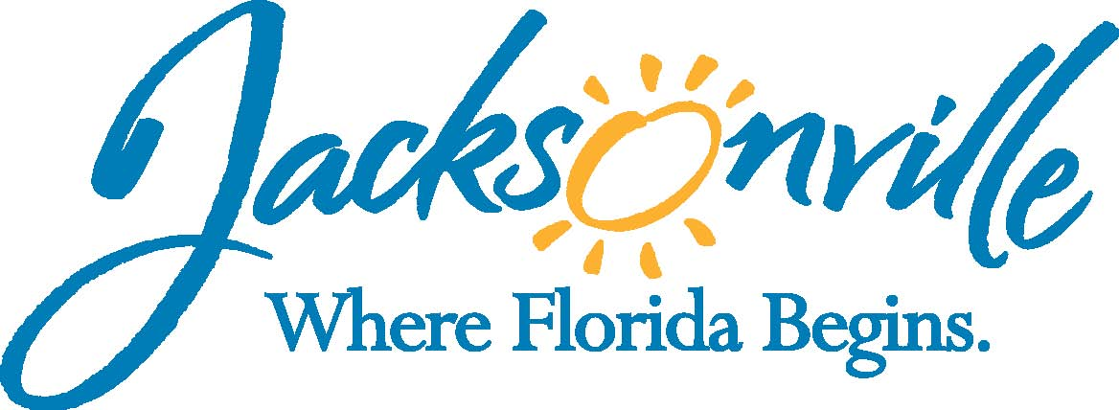

City of Jacksonville
Office Grants & Contracts Compliance
Public Service Grant Council
Application Oral Presentations

Ed Ball Building, 8th Floor, Room 851

Wednesday, October 14, 2016 11:00 a.m.
PSG Chair: Roshanda Jackson

Public Service Grant Council Member Attendance
X | Roshanda Jackson, Chair | X | Deborah Johnson
X | Dr. Jerry Fliger, Vice-Chair | X | Chris Warren
X | Iris Young | E | Bob Baldwin
X | Carol Brock | E | Tameka Holly
X | Dr. Marcie Turner | X | Lara Diettrich
X | Dr. Georgette Dumont
Quorum Present: YES
Staff: John Snyder
Damian Cook
Sandra Stockwell, OGC
Council Liaison: C/M Joyce Morgan (City Council)

- Welcome & Introduction of PSG Council Members – Ms. Jackson
The Public Service Grant Council (hereinafter “PSGC”) meeting was called to order by Ms. Jackson, Chair, at 11:07 a.m. The PSGC members and staff introduced themselves.

- Public Service Grant Council Meeting Minutes Approval– Ms. Jackson
Ms. Young moved approval of the minutes from September 14, 2016. Dr. Fliger seconded the motion. The motion passed unanimously.

- Initial Ranking and Funding List for each 2017 PSG Application belonging to a Priority Population or Priority Need – Mr. Snyder
Mr. Snyder went over the funding breakdown by Priority Population listing them from highest to lowest (see attached).

Dr. Fliger open the discussion regarding not funding one agency who received 3 one hundredth of a percent less than an agency who is getting funding. Ms. Stockwell stated that the ordinance calls for funding from highest score down, so staff carried out the percentage to last decimal. Ms. Jackson stated that because the way the ordinance is written there really is no option. Dr. Fliger stated that he would like to bring this up to the rules committee meeting in November.

Ms. Stockwell stated that staff is keeping a list of administrative items that they would like to add to a “glitch bill list”. Ms. Jackson asked if staff could present this list at the next meeting. She also charged members with coming up with some items of their own.

Ms. Jackson opened up and asked for comments from agencies.
Mr. Higginbotham from I M Sulzbacher spoke about the issue being lack of funding.

Mr. Howland from Jax Speech and Hearing spoke about how happy he is now to only miss the cut-off my six tenths of a point instead of 7 whole points. He also spoke about feeling better about the scoring and evaluation than last year.

Ms. Jackson spoke about the need for additional funding and asked PSG C/M to advocate to the Mayor and City Council for additional funding.

C/M Morgan talked about working with agencies and understands what agencies are going through. She also spoke about how agencies need to diversity their funding and encouraged the council to come up with recommendations regarding enhancing how this money is distributed to agencies.

Ms. Bradshaw with Learn To Read spoke about what she and other agencies can do to help increase funding. Ms. Jackson stated the same charge to agencies to meet with the Mayor and City Council regarding increase in funding.

Dr. Dumont stated how stressful it is to score these applications because she knew that her score would mean an agency is getting funding and another agency is not and how that will directly impact someone.

Mr. Warren and Ms. Diettrich talked about when an agency meets with the Mayor or City Council that they bring someone from their board. They both talked about how these are the people who are usually helping them fundraise and these are the people they know from other committees and meeting and that will carry more weight.

- Adopt/vote a tentative ranking – Ms. Jackson
Ms. Jackson called for a vote on the tentative ranking and funding allocation. Dr. Fliger motioned to adopt the tentative ranking and funding allocation as read and presented to the PSG Council. Dr. Dumont seconded the motion. The motioned passed unanimously.

Ms. Jackson stated that there needs to be another meeting and final vote on ranking & funding will come after the appeals but before 11/1.

- Copies of each requesting agency’s completed score – Mr. Snyder
Mr. Snyder stated the Appeal Board is scheduled to meet October 21, 2016 at 2:00 PM in this room. He also stated that as soon as today’s meeting is over he will make everyone’s average score available via e-mail as well as their individual’s score and comments from reviewers.

- Appeal Procedure – Ms. Stockwell
Ms. Stockwell went over the appeals process according to Chapter 118.810 indicating that an agency has 5 days to put in writing an appeal and this appeal must be for one of the following reasons;
- Mathematical error
- An error by the application scorer in deduction points for something that they did not see was there when it was actually provided
- A minor irregularity in the application contents
- An error made by PSG Council staff regarding eligibility determination (appeals period for this closed)
- Being on the Council Auditor’s Non-Compliance list (appeals period for this closed)

- Open Discussion
Dr. Turner asked about the Rules Committee meeting and would like information on this meeting. Ms. Diettrich also asked for this calendar invite.

Mr. Warren stated that he would like to vote on staff’s glitch bill items and any other item that is presented to the Rules Committee.

The PSG Council decided to meeting October 31, 2016 at 9:00 AM for the final ranking and allocation.

- Public Comments
There were no public comments

- Adjourn
Meeting was adjourned at 11:55 AM
Next Meeting Dates 10/31/2016 & 11/09/2016
Recorder: John Snyder
Completed – 10/21/2016
An audio recording is available upon request

