INTRA-GOVERNMENTAL SERVICES

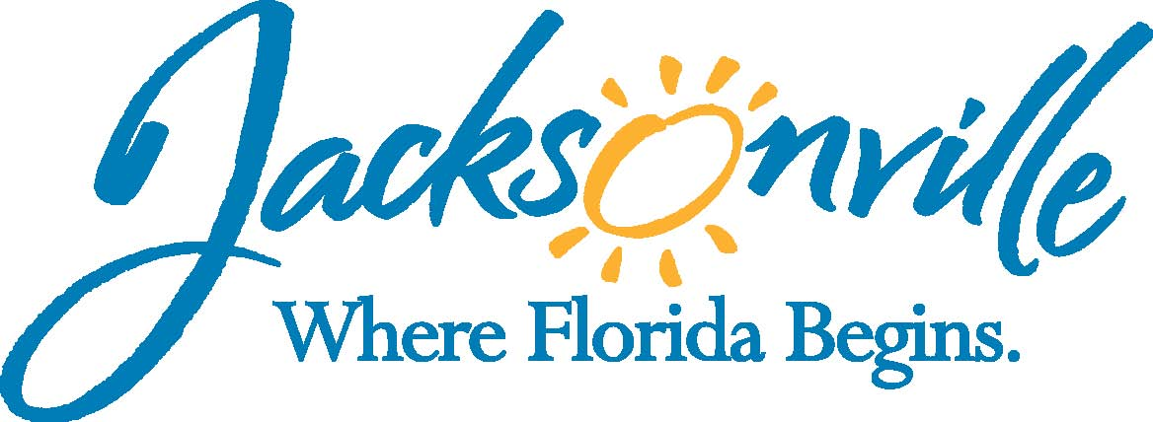

City of Jacksonville
Office Grants & Contracts Compliance
Public Service Grant Council
Application Oral Presentations

Ed Ball Building, 8th Floor, Room 851

Wednesday, August 10, 2016 11:00 a.m.
PSG Chair: Roshanda Jackson

Public Service Grant Council Member Attendance
X | Roshanda Jackson, Chair | X | Deborah Johnson
E | Dr. Jerry Fliger, Vice-Chair | X | Chris Warren
X | Iris Young | X | Bob Baldwin
X | Carol Brock-via phone | X | Tameka Holly
X | Dr. Marcie Turner | X | Lara Diettrich
X | Dr. Georgette Dumont
Quorum Present: YES
Staff: John Snyder
Damian Cook
Sandra Stockwell, OGC
Council Liaison: C/M Joyce Morgan (Darren Mason-ECA)-City Council

- Welcome & Introduction of PSG Council Members – Dr. Fliger
The Public Service Grant Council (hereinafter “PSGC”) meeting was called to order by Ms. Jackson, Chair, at 11:01 a.m. The PSGC members and staff introduced themselves.

- Public Service Grant Council Meeting Minutes Approval– Ms. Jackson
Dr. Dumont moved approval of the minutes from July 13, 2016. Dr. Turner seconded the motion. The motion passed unanimously.

- Streamlink/Amplifund Reviewer Scoring Training- Mr. Snyder
Mr. Snyder asked if any of the PSG Council members had any issues with accessing the applications. He indicated that he sent out the invites; however, he does not have access to see scores until after October. Several members indicated that they have logged in and begin reviewing applicants. Mr. Snyder reiterated that if there are any issues to please contact him and that if it was a technically issue that he could not handle he would refer it to the provider.

- 2017 PSG Applicant Breakdown by Priority Population-Mr. Snyder
Mr. Snyder went over the revised Priority Population spreadsheet after the Appeals Board meeting. Mr. Cook went over the process of the Appeals Board as well summarized the outcome. Ms. Jackson spoke about the Appeals Board did bring some further improvements to Chapter 118 to light and is a successful process improvement.

The minutes of the Appeals Board was included in the packet and is available on-line

- COJ Budget Finance Hearing- Ms. Jackson
Ms. Jackson spoke about meetings with C/M Newby and C/M Schellenberg. She also stated the PSG Budget Hearing starts at 9 AM Thursday, August 11th. Mayor will give 15 min overview then there will a couple of general items and that PSG is number 17 and that all members and applicants are invited to attend. There was some discussion about lobby for extra funding.

Ms. Diettrich asked for clarification regarding the PSG Budget process, as well as the total dollar amount requested and the total dollar amount received this year. Mr. Snyder clarified the fiscal years and what is being requested by the Mayor and budget process.

Mr. Warren stated that as a Mayoral Appointee he feels uncomfortable lobbying City Council for more funding than what the Mayor proposed. Ms. Jackson and Ms. Young pointed out that on the web-site are Goals for PSG Council and one of these goals is to lobby for additional funding which could include both lobbying the Mayor and/ or City Council for additional dollars.

Ms. Jackson spoke about the lobby packet that Ms. Adam and her sub-committee worked on last year and asked Mr. Snyder to forward that to all members. Mr. Baldwin and Dr. Dumont asked about other funding City wide as well as funding to other non-profits in the community. Mr. Snyder indicated that he could forward the list of schedule in the budget that has a number of funding recommendations such as; City-Wide Activities, Schedule of PSG to include Cultural Council, and other Trust Funds administered by this office, Children’s Commission Budget, Housing to include CDBG, HOPWA, & ESG, and Jax Journey recommendations. Mr. Cook indicated that is the charge of the PSG Council Budget Sub-committee to recommend a budget amount to the Mayor for FY 18.

- Open Discussion
Mr. Bob Baldwin asked that it be noted for the record that he is the Board Chair for Hubbard House. Ms. Stockwell indicated that this position is a volunteer position and that he does not personally benefit in any way from PSG funding that Hubbard House may or may not receive.

- Public Comments
There were no public comments

- Adjourn
Meeting was adjourned at 11:52 PM
- Next Meeting Date 9/14/2016
Recorder: John Snyder
Completed – 9/80/2016
An audio recording is available upon request

