INTRA-GOVERNMENTAL SERVICES

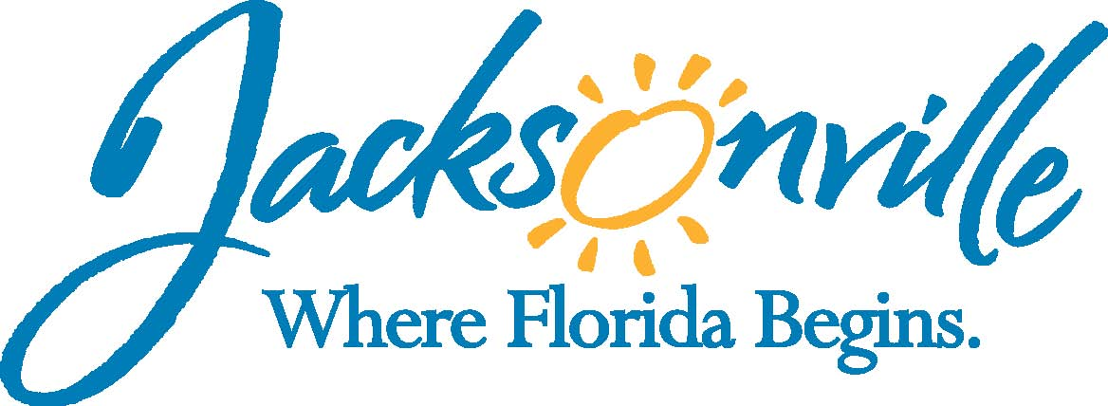

City of Jacksonville
Office Grants & Contracts Compliance
Public Service Grant Council
Application Oral Presentations

Ed Ball Building, 8th Floor, Room 851

Wednesday, March 09, 2016 10:00 a.m.
PSG Vice-Chair: Dr. Jerry Fliger

Public Service Grant Council Member Attendance
X | Roshanda Jackson, Chair | X | Carol Brock
E | Kevin Monahan | X | Dr. Marcie Turner
E | Iris Young | E | Dr. Georgette Dumont
X | Dr. Jerry Fliger | X | Deborah Johnson
Quorum Present: YES
Staff: John Snyder
Damian Cook
Sandra Stockwell, OGC
Council Liaison: C/M Anna Brosche - City Council

- Welcome & Introduction of PSG Council Members – Dr. Fliger
The Public Service Grant Council (hereinafter “PSGC”) meeting was called to order by Dr. Jerry Fliger, Vice-Chair, at 11:17 a.m. The PSG Council members and staff introduced themselves. Ms. Jackson joined the meeting at 11: 48 am. There was some concern regarding the question of quorum as being the 50% +1 of members (8) or 50% +1 of PSGC (15). Ms. Stockwell clarified that it is 50%+1 of members total appointed and approved by City Council not the total PSGC available seats.

- Public Service Grant Council Meeting Minutes Approval– Dr. Fliger
Ms. Jackson moved approval of the minutes from February 10, 2016. Ms. Brock seconded the motion. The motion passed unanimously.

- Discussion of Proposed Funding for FY 2017 – Ms. Jackson
C/M Broshce discussed last year’s budget recommendation from the Mayor’s Office and how City Council added the approximately $600,000 for PSG funding. She then discussed City Council’s PSG Sub-Committee and how the process was changed to allow the PSGC to just request an amount for inclusion in the budget to the Mayor’s Budget Review Committee (MBRC). Additionally, she spoke about how several City Council members had reservation about the PSGC reducing the requested cap below the ordinance amount of $150,000. C/M Brosche then discussed how once MBRC determines an amount for the budget that City Council will review the lump sum amount as part of the normal budget process, and the PSGC will distribute the funding based on the Ordinance.

Dr. Fliger asked that members and public look at the spreadsheet (see attached), which goes back to 2010 concerning the Priority Populations, the requested amounts, and the amount received. Dr. Fliger spoke about how the request looks to be consistent with only some minor fluctuation.

Dr. Fliger read the ordinance and the requirements of Chapter 118.802 (see attached)

Several members discussed the amount requested as being the request to the MBRC or an amount that maybe between what was requested and what was awarded last year.

- Public Commits related to Funding Request – Ms. Jackson
Dr. Fliger asked for comments from the members in attendance; however, there were no comments.

- Vote on Requested Funding for FY 2017
Dr. Turner posted requesting to MBRC $3,931,058 which is the amount requested last year by PSG Applicants ($3,781,058), plus an additional $150,000 due to the increase in the cap amount. Ms. Jackson seconded the motion. The motion was approved by a vote of 4 to 1 (Dr. Fliger).

- Priority Population Legislation–Mr. Snyder
Mr. Snyder spoke about 2016-183 and how it is same as in years past minus all the attachments, which are now part of the ordinance. The legislation is scheduled to be introduced this week, but will not go before Finance and Recreation, Community Development, Public Health & Safety until the first week in April. Dr. Fliger asked if Mr. Snyder could send out an e-mail reminder to the PSGC so that in addition to Ms. Jackson and himself other members of the PSGC could be in attendance. Ms. Stockwell confirmed that it is set for Finance’s April 4th 9:30 A.M. meeting and RCDPHS April 5th at their 9:30 A. M. meeting.

- PSG Revised Schedule Legislation- Mr. Snyder
Mr. Cook spoke about how 2016-184 will go before Finance, RCDPHS, & Rules next week as an emergency based on the need in the community as well as the timing of funding. Mr. Snyder stated Administration would like the support of the PSGC as an Emergency to City Council. Ms. Jackson moved that the PSGC supports the Mayor’s request that this be an emergency. The motion was seconded by Dr. Turner and approved the motion unanimously.

C/M Brosche acknowledge support of emergency by Administration and the PSGC.

- PSG Council Training – Mr. Cook/ Mr. Snyder
Dr. Fliger spoke about the PSG Council training being open to the public; however, there will be no vote taken and thus no public discussion. He also stated that this training will also be similar to training that will be required in a couple months after the passage of the Priority Population.

- Open Discussion
C/M Brosche talked about how it is her understanding that C/P Anderson has three candidates to the PSGC in the works. However, they may be at various stages. Additionally, C/M Brosche spoke about her working with Mayor’s Office on a couple of other candidates. It is her hope that the PSGC is full before the scoring of the applications.

Dr. Fliger spoke about how he is grateful on behalf of the PSGC and the non-profits that are served on the work that C/M Brosche has accomplished during the City Council’s Sub-Committee on PSG.

- Public Comments
There were no public comments

- Adjourn
Meeting was adjourned at 11:47 PM
- Next Meeting Date 04/13/2016

Recorder: John Snyder
Completed – 03/18/2016
The written minutes for this meeting are only an overview. A verbatim audio recording is available upon request.

Attachment 1

Attachment 2

Section 118.802. Annual Lump Sum Appropriation for Public Service Grants.
On or before April 1st of each year, the PSG Council shall submit to the Mayor’s Budget Review Committee (“MBRC”) for review an annual lump sum appropriation request for all Public Service Grants to be awarded annually under this Part. The PSG Council shall include in such request relevant information regarding the appropriation amount and the need for Public Service Grants in the community. MBRC shall review and consider the PSG Council’s appropriation request and include a lump sum appropriation request for Public Service Grants in the Mayor’s proposed annual budget for the upcoming fiscal year. The City Council in its sole discretion shall determine the final annual lump sum appropriation amount in the annual budget ordinance for Public Service Grants. The PSG Council shall not award or allocate funding to requesting agencies under this Part until after the City Council has approved the annual budget ordinance.

