INTRA-GOVERNMENTAL SERVICES

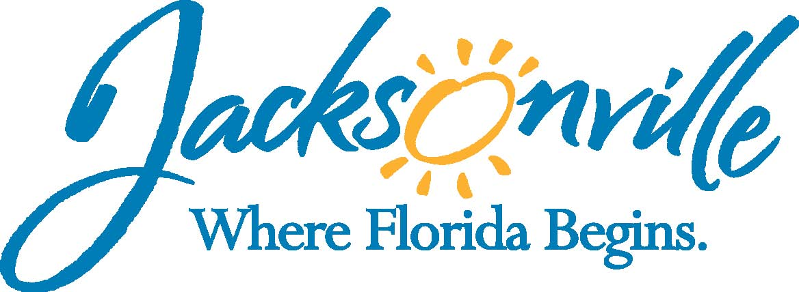

City of Jacksonville
Office Grants & Contracts Compliance
Public Service Grant Council
Application Oral Presentations

Ed Ball Building, 8th Floor, Room 851

Wednesday, December 09, 2015 11:00 a.m.
PSG Chair: Roshanda Jackson

Public Service Grant Council Member Attendance
X | Roshanda Jackson, Chair | X | Dr. Jerry Fliger
E | Kevin Monahan | X | Autumn Tomas
U | Dorrell Briscoe | X | Carol Brock
X | Iris Young | X | Dr. Marcie Turner
Quorum Present: YES
Staff: John Snyder
Damian Cook
Sandra Stockwell, OGC
Council Liaison: C/M Anna Brosche-City Council, Jeneen Sanders

- Welcome & Introduction of PSG Council Members – Ms. Jackson
The Public Service Grant Council (hereinafter “PSGC”) meeting was called to order by Ms. Roshanda Jackson, Chair at 11:01 a.m. The PSG Council members and staff introduced themselves. Dr. Marcie Turner formally introduced herself as new PSG C/M. Ms. Jackson introduced Dr. Georgette Dumont (Ordinance 2015-816), & Ms. Debbie Johnson (Ordinance 2015-817) as potentially two new PSG Council Member. Dr. Dumont & Ms. Johnson discussed their background and experience in the community and with grants and grant making.
- Public Service Grant Council Meeting Minutes Approval– Ms. Jackson
Dr. Fliger moved approval of the minutes. Ms. Tomas seconded the motion. The motion passed unanimously. Ms. Jackson and Ms. Sanders had discussion regarding Mr. Briscoe and this being his third unexcused absence. Ms. Sanders indicated that she will inform C/M Brosche.
- Review and Approve the 2015 PSG Annual Report – Mr. Snyder
Mr. Snyder went over the PSG Annual Report also noting its inclusion now in Chapter 118 part 8. Ms. Jackson asked that Mr. Snyder revise the heading. Dr. Dumont noted that some of these measures are quantitative measures and she would like to move to more qualitative measures. This was also a concern noted by Ms. Tomas and Ms. Jackson. Ms. Brock asked if this could be sent to the Public Information Office, so that the community knows as well. Dr. Fliger motioned to approve the Annual Report with the noted changes and authorizing Ms. Jackson to sign and present to Council President. Ms. Brock seconded motion. The Motioned Passed unanimously.
- Discussion from City Council PSG Sub-Committee – Ms. Jackson
Ms. Jackson noted that the Council Sub-Committee agendas for the last two meetings and indicated that this is included with item #V.
- Discussion Regarding Proposed New Chapter 118 – Ms. Hodges
Ms. Hodges went over the new proposed changes to Chapter 118 part 8 (see attachment A-highlights) with an expected passes in Late January or early February. After discussing the required training, Ms. Hodges indicated that she would get with Council to add the ability to have multiple training sessions throughout the year instead of one training session.
- Discussion Regarding PSG New Application – Mr. Snyder
Mr. Snyder went over the revised PSG Application Template and revised timeline, which was approved by Council and is directly out of the ordinance. Ms. Tomas asked that we get with the sub-committee and add the margins to the application requirements. Mr. Snyder also noted that the PSGC Scoring Sheet is still under review.
- Priority Population/ Priority Needs Discussion – Mr. Snyder
Mr. Snyder discussed the revised date and the fact that Council wanted more of a defined Priority Population, which is why the renewal option was not adopted by Council Sub-Committee. Ms. Hodges also added that C/M Boyer moved the required date to March 1st, so that the PSGC can have a more in depth analysis of the Priority Populations. Dr. Fliger had concern that the evaluations were not just done evenly as something’s necessitate more weight than others.
- PSG Council Application Evaluation Training – Mr. Snyder
Mr. Snyder talked about the importance of the training and how we will conduct it as soon as Council Approves, but wanted to make sure all members knew the ramifications if a member does not attend the training (i.e. cannot score any application). Dr. Fliger indicated that this could be done at the March or April meeting and opened to the public. Mr. Cook verified that this is exactly what he was thinking. Ms. Jackson asked Mr. Snyder to send out a doodle invite regarding everyone’s availability and to try and shut for a February date first.
- Open Discussion
Ms. Jackson stated that at the next meeting in January (1/13/2016) we will have elections of President and Vice-President and stated this would be the second or third agenda item.
- Public Comments
Ms. Martha Cox with Family Foundation discussed their Mental Health Counseling Impact program and some of the successes.
- Adjourn
Meeting was adjourned at 12:45 PM

Recorder: John Snyder
Completed – 12/11/2015
The written minutes for this meeting are only an overview. A verbatim audio recording is available upon request.
Attachment A
Highlight of Chapter 118 part 8

Section 118.801-Purpose
- The PSG Council is not added as an official Chapter 80 with the structure of the City of Jacksonville- 15 members, 8 Mayor & 7 Council, 4 with grant experience
- Going to stagger members terms- currently all expire on 12/31/2016
- Removal by Mayor and Council President only
- Conflict of interest-employee, Board Member, or consultant of applicant
- Must meet monthly
- Annual Training
Section 118.802-Annual Lump Sum Appropriation
- PSG Council submit to MBRC a request for a “Lump Sum Appropriation” for inclusion in budget
- City Council shall determine the final amount
- PSG Council shall not allocate funding until after budget approved by Council
Section 118.803-Grant Administrator; Responsibilities
- Required Annual Training Course for PSG Council Members
- Mandatory Application Workshop for applicants w/n 30 days of Priority Population/ Need legislation passage
- Courtesy Review of Application Checklist by staff until 2 weeks before due date
- Annual Report to Council
Section 118.804-Priority Population or Needs
- Due date is now March 1st
  - Must include reason for need
  - The percent of funding
  - Awarded through application or RFP
- Council must adopt by May 1st
Section 118.805-Eligible to Apply for PSG
- No program can receive a PSG Award if program is receiving funding through another COJ program such as; Cultural Council, Art in Public Places, Children’s Commission, Downtown Investment Authority/ OED, Housing & CDBG, and Social Services Division
- Eligible Documents
  - Good Standing Certificate from FL Division of Corp-$8.75
https://services.sunbiz.org/Filings/CertificateOfStatus/StandaloneCertificateStart
  - Current years Charitable Solicitation Permit
  - 3 years tax returns
  - Mandatory Application Workshop
  - OGC Affidavit
    - Operate in Duval County
    - Priority Population to serve
    - Program not eligible to receive from another COJ program
    - Request is not over 24% (aggregate) of average 3 years agency revenue
    - In compliance with any COJ agreement
    - In compliance with any Federal, State, Local laws, rules, regulations
- Staff has 72 hours after submission to notify agency
- Agency can appeal to Appeal Board (118.810)
- Council can waive with 2/3 vote of Council
Section 118.806-Application Requirements
- Due July 1st
- Application Content
  - Eligibility Documents
  - Cover page
  - Agency Background & Experience
  - Program Overview
  - Program Activities
  - Program Management & General Overhead
  - Operating Budget & Budget Narrative
  - Program Impact & Effectiveness
- Application Format
- Interviews
  - Notify before May1st (scoring sheet)
  - All or nothing
- Disqualification of Application-72 hours and appeals
Section 118.807-Review, Evaluation & Scoring
- Committee
  - 5 per committee
  - Can serve in more than 1
  - Each committee member must score all applications
  - If less than 8 members all must score all applications
- 20 point more or less than average discarded
- Score sheet available May 1st
- Evaluation Criteria-TBD by Council Sub-Committee
Section 118.808-Funding Allocation by PSGC
- $150,000 –no change
- Must submit scores on October 1st
- Must not submit recommendations until after COJ budget approval and on November 1st
Section 118.809-Budget Amendments
- Staff may only amend budget up to 10%
Section 118.810-PSG Appeals Board
- 3 Members-Grants Administrator-Chair, Chief of Procurement, & PSGC Chair
- Must notify PSGC
- Reason for an appeal
  - Mathematical error
  - Error by scoring in deducting points for something that is not there, which was in fact submitted
  - Minor irregularity-signature, error in budget spreadsheet by staff
  - Error in eligibility determination
- 5 business days to appeal must contain; which of above, w/n 5 business days, & amount of grant tentative funding allocation
- Board meet as soon as possible-Final determination, PSGC meeting adopt final allocation
Section 118.811-PSG Appropriation Outside of Annual Budget (no change)
Section 118.812-Dates & Time-next business day

