INTRA-GOVERNMENTAL SERVICES

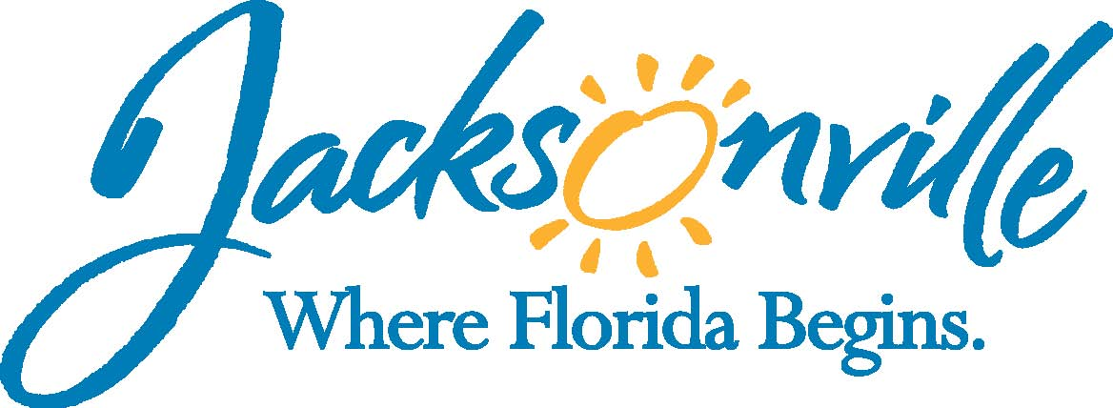

City of Jacksonville
Office Grants & Contracts Compliance
Public Service Grant Council
Application Oral Presentations

Ed Ball Building, 8th Floor, Room 851

Wednesday, October 14, 2015 11:00 a.m.
PSG Chair: Roshanda Jackson

Public Service Grant Council Member Attendance
X | Roshanda Jackson, Chair | X | Dr. Jerry Fliger
E | Kevin Monahan | X | Autumn Tomas
U | Dorrell Briscoe | X | Iris Young
 |  | X | Carol Brock
Quorum Present: YES
Staff: John Snyder
Damian Cook
Sandra Stockwell, OGC
Council Liaison: C/M Anna Brosche-City Council, Jeneen Sanders

- Welcome & Introduction of PSG Council Members – Chair, Roshanda Jackson
The Public Service Grant Council (hereinafter “PSGC”) meeting was called to order by Ms. Roshanda Jackson, Chair at 11:01 a.m. The PSG Council members and staff introduced themselves. Ms. Jackson introduced Ms. Carol Brock (Ordinance 2015-653) as the new PSG Council Member, Ms. Brock discussed her background and experience with grants and grant making.

- Approval of Meeting Minutes from September 09, 2015 – Chair, Roshanda Jackson
Dr. Fliger moved the revised minutes with the change of Mr. Briscoe absence changing to unexcused. Ms. Tomas seconded the motion. The motion passed unanimously. Ms. Jackson asked if Mr. Briscoe ever e-mail me regarding his absence for this morning’s meeting. Mr. Snyder indicated that he had not received an e-mail. Ms. Jackson stated to have Mr. Briscoe’s absence be unexcused for today’s meeting. As a follow-up, When I returned to my office I received an e-mail from Mr. Briscoe the he will not be able to attend this meeting.

- Introduction - Discussion from City Council PSG Sub-Committee- Ms. Jackson
Ms. Jackson went over the initial charge of the City Council Sub-Committee on PSG indicating that the committee is now on their second charge. “Review and assess the PSG process and procedures (outlined in Section 118.801). Report your findings and recommendations to the Finance Committee and City Council. If the Special Committee determines that legislative changes are required, work with OGC to prepare the proposed legislation.”

Mr. Snyder stated that in the meeting C/M Brosche stated the next meeting will be 10/28 and this meeting will conclude the initial legislative changes. Then Procurement will give an overview of the Procurement Process followed by questions and answers.

Dr. Fliger spoke about his concerns regarding PSGC to the committee stating one of the biggest issues is the number of members on the committee and not being at 13 during the critical time of application grading. In addition, he talked about the need to develop an appeals process, and his objections to following a RFP process,

Ms. Tomas asked Ms. Jackson for her option and thoughts of the RFP process. Ms. Jackson spoke about issues regarding small organizations, time table for an RFP, if not selected it could be 3 years before you get any COJ PSG funding.

Mr. Cook responded stating that the RFP process is not a guarantee of three years it is up to agency achieving the performance measures. He also stated that there is not a push for an RFP, but more for multi-year contract. He then went into how an RFP would have to be more specific than current Priority Population. He also stated that one issue with an RFP is that this body would be defining what we want to pay for and not being able to solicit an idea from the community.

Ms. Young asked what will be PSGC responsibility will be with an RFP. Mr. Snyder responded indicating that the Jax Journey has used the RFP model for years now and that their board does have to define and approve a “Scope of Service” and approve a “Score Matrix” similar to scoring now, but that it would only need to develop a “Scope of Service” once every three years.

Ms. Stockwell stated that this body would have to grade the RFP and then your recommendation would go to either the GGAC or PSEC for approval and signature of Mayor. This body would still have the responsibility of grading and reviewing the applications.

Ms. Jackson then asked for commits from the audience on this topic.

Ms. Hepler from Catholic Charities spoke how she feels the Sub-Committee is listening and just does not want to do RFP without thorough input.

Mr. Bell from L’Arche Harbor House spoke about training, and need for more members

Dr. Marcie Turner stated that she has applied to be on this board and talked about her path to get on this board and how Administration and City Council need to advertise more to get quality members.

Ms. Tomas stated that members are also looking into how funds are used like for administrative expenses and other overhead cost.

- Discussion Regarding PSG Application – Ms. Jackson
Mr. Snyder mentioned that there does not need to be a vote today; however, there is a quorum and if you don’t vote on it today then you will need to meet in November and vote on it and the Priority Population. Additionally, the next meeting date is November 11th, which is Veterans Day and the COJ along with other Government Offices is closed. Therefore, we would need to schedule another meeting.

Dr. Fliger and Ms. Jackson both stated that the Sub-Committee really had no issue with the actual application more so the process. Mr. Snyder added that everything in Section 118 is in the application, in addition to other questions. Furthermore, the application was changed last year after the Non-Profit Center had a meeting with local agencies on some suggestive changes.

At the end of the meeting, Ms. Stockwell pointed out that the PSGC discussed the application, but did not vote on approval.

Dr. Fliger asked that if an application is being rejected can staff call for missing information. Mr. Cook stated that he is uncomfortable with staff providing this due to no specify being provided in the Ordinance Code.

Ms. Baker with Community Connections talked about how the Children’s Commission application will have a mandatory checklist or have staff do a non-mandatory check 3 days before.

Mr. Cook talked about of the discrepancy between 118.805 & 118.806 and that by March 15th the Sub-Committee should have their recommendations legislative changes. Ms. Stockwell stated that since your recommendation will be moving at the same time as the Sub-Committee the two will most certainly have similar language. She also stated that appeals process will not be longer than 5 days. This is the time frame that the Sub-Committee is discussing.

Ms. Tomas stated that having staff do this then we are rewarding behavior that should not be rewarded. Agencies will complain and we will be back here again next year because someone did not get what they wanted.

Mr. Bell from L’Arche Harbor House spoke about how it should be the member’s responsibility to re-determine rather something is missing or not. So once this process takes place City Council members can conclude that all documentation has been included.

Ms. Tomas spoke about how the PSGC modified the process to set up a sub-committee to discuss applications and any missing items. However, City Council is against this idea because of the “Group Think” scenario.

Ruth Hepler with Catholic Charities spoke about applicant eligibility criteria and scoring criteria. If an applicant does not meet the applicant eligibility then they don’t meet that objective criteria and should not be scored. If they are missing something from the scoring criteria then they should subjectively have points taken away. She also stated the COJ needs to advertise for positions on boards and commissions.

Ms. Jackson asked Mr. Snyder about his application checklist. Mr. Snyder stated that last year the checklist was the attachments and a signature; however, the Sub-Committee stated the checklist should only be what is in 118.805. Therefore, that is the current checklist. Ms. Stockwell indicated that the problem is in 118.806 with these application eligibility being “shall have or required”, but staff not being able to use it as a screening checklist because of its subjectivity.

Dr. Fliger motioned to accept the current application as the 2017 application with minor numerical updates and was seconded by Ms. Tomas. The motion passed unanimously.

- Priority Population/ Priority Needs Discussion – Ms. Jackson
Ms. Jackson spoke about one issue in the community not be addressed by any COJ funding or other funding in the community is support for housing modifications (repairs) for individuals in order to keep them in the home and/ or not be forced into a living facility especially for seniors rather or not they are homebound.

Dr. Fliger asked for the current Priority Populations. He then stated that under the current Priority Population they could submit a grant application under Low-Income to assistance all low-income individuals rather they are disabled, senior, or just in need. Ms. Tomas agreed that the current Populations would serve the requested need in the community for this service to those homebound individuals rather or not they are elderly or not.

Mr. Snyder pointed out that it was Elder Source who stated the requested need for seniors to remain in their home and that if you left the percentage alone they would then be competing with these new applications for assistance to homebound elderly. Ms. Jackson and Dr. Fliger stated that they would want to make sure that this type of service was available to senior who may not be homebound, but still in need of minor repairs.

Ms. Lanier from The ARC Jacksonville spoke about the RFP and how it would allow you to focus more on what you want to focus on and not make the grant application so uncertain. She also spoke about the JCCI study. Dr. Fliger responded that JCCI and other agencies came and spoke at the last meeting.

Dr. Fliger reread the Priority Population and percentage for the record.
- Homeless Persons & Family 35%
- Low-Income Persons & Family 40%
- Adults with Physical, Mental, or Behavioral Disabilities 20%
- Low-Income Homebound Elderly 5%

- Priority Population/ Priority Needs Recommendation – Ms. Jackson
Ms. Tomas made a motion to approve the current FY 2016 Priority Population with the same percentages and definitions for FY 2017 providing staff to update any figures from the Federal Government upon their release. The motion was seconded by Ms. Brock. The motion passed unanimously.

- Public Comments (Please fill out a card if you wish to speak on a topic that isn’t on the agenda)
Ms. Sanders Legislative Aide to Ms. Brosche gave the dates of the up-coming Sub-Committee meetings;
- 10/28/2015 9:30 AM - 11:30 AM
- 11/09/2015 9:30 AM – 11:30 AM
- 11/18/2015 1:30 PM – 3:30 PM
- 12/09/2015 1:30 PM – 3:30 PM
Ms. Sanders also added that C/M Brosche is anticipating the dialogue we discussed here today and that it is early in the process and evaluating daily and to keep the questions coming.

- Adjourn
Meeting was adjourned at 12:52 PM

Recorder: John Snyder
    - Completed – 10/15/2015
The written minutes for this meeting are only an overview. A verbatim audio recording is available upon request.

