INTRA-GOVERNMENTAL SERVICES

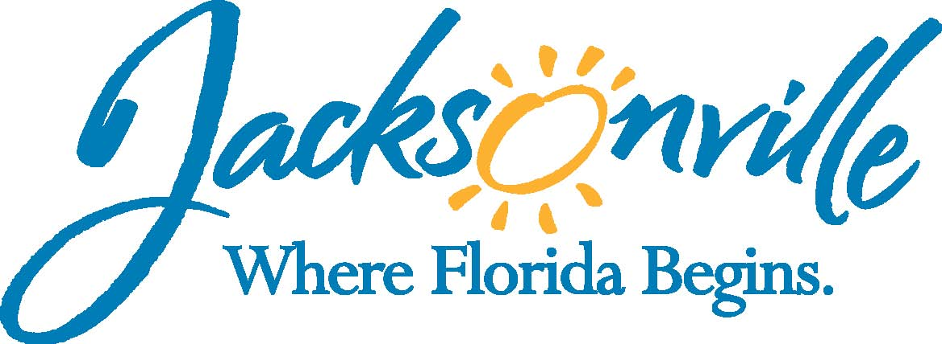

City of Jacksonville
Office Grants & Contracts Compliance
Public Service Grant Council
Application Oral Presentations

Ed Ball Building, 8th Floor, Room 851

Wednesday, September 09, 2015 11:00 a.m.
PSG Chair: Roshanda Jackson
Quorum Present: YES
Public Service Grant Council Member Attendance
X | Roshanda Jackson, Chair | X | Iris Young
E | Kevin Monahan | E | Chris Rose
X | Dr. Jerry Fliger | U | Dorrell Briscoe
X | Autumn Tomas
Staff: John Snyder
Damian Cook
Sandra Stockwell, OGC
Council Liaison: C/M Anna Brosche-City Council, Jeneen Sanders
C/M: Joyce Morgan-City Council, Daren Mason

- Welcome & Introduction of PSG Council Members – Chair, Roshanda Jackson
The Public Service Grant Council (hereinafter “PSGC”) meeting was called to order by Ms. Roshanda Jackson, Chair at 11:11 a.m. The PSG Council members and staff introduced themselves. Ms. Jackson introduced Ordinance 2015-653 of Ms. Carol Brock as a potentially new PSG Council Member who is currently going through the legislative process. Ms. Jackson spoke to members in the audience and how the PSG Council needs more members and they can ask members of their boards or individuals they know with grant experience to become members of this council.

- Approval of Meeting Minutes from July 8, 2015 – Chair, Roshanda Jackson
Dr. Fliger moved the revised minutes with the removal of “next year to wait until” from the top of page 2. Ms. Tomas seconded the motion. The motion passed unanimously

- State of Nonprofit Jacksonville – John Snyder
Mr. Snyder reviewed Chapter 118.803(e)1 & 118.805(a). Ms. Jackson went over the 4 priorities of the new administration; Crime-A Safer Jacksonville, Job Growth/Economic Development, A world class education for every student, A safer Jacksonville for every citizen, & Fiscal accountability for every tax dollar.
- Grants administered through Social Services Division-Johnnetta Moore, Chief
Ms. Moore went over the grants/ programs funding through the Social Services Division stating that some of the same agencies get funding from them, but for different programs and services. Ms. Moore then went over the $12,018,157 from the various funding sources to include General Revenue, and a number of grant dollars that are awarded to non-profits.

- Mayor’s Disability Council
Mr. Snyder went over an e-mail from Disabled Services Division and the Mayor’s Council on Disability and their view of needs in the community to include; A Deaf Advocacy Program, Autism Spectrum Programs, & Mental Health programs.

- Jacksonville Community Council, Inc. (JCCI)- Clayton Davis, CEO
Mr. Davis indicated that the JCCI’s Vice-President, Laura Lane, who gave the presentation. She indicated that there were a number of “Red Flag Indicators”; Unemployment, Median Household Income, # of Food Stamps recipients, Infant Morbidity Rate, Serious Bicycle accidents.

Ms. Lane stated there were three “Inquiries”
- Mental Health- 60% of adults never receive treatment for their diagnosis, and the current delivery system is fragmented resulting in limited access, lack of coordination, resulting in a significant financial impact to individuals in the community
- Elderly-currently 25% of population is over 55. Additionally, 44% respondents say they have no funds left after bill for retirement
- The need of System, Long-term financial planning- currently 105,000 households in Jacksonville spend more than 30% of income on Housing, and 20% of household are on Food Stamps. Ms. Lane than asked members for their vision, and for them to serve on the JAX 2025 project.

- Elder Source – Northeast Area Agency On Aging – Linda Levin, Executive Director
Ms. Linda Levin went over their PowerPoint presentation highlighting demographics and a summary of needs to include;
- Funding to support Caregiver programs
- Issue with transportation services such as getting to bus stops, lack of sidewalks, shelters & benches, transfers, & scheduling confusion
- More Housing funding and programs to age in place
- Mental Health funding for seniors
- Assistance with waiting list for the following; Medicaid Managed Long-Term Care, Alzheimer Disease Initiative, Community Care for Elderly, & Meals on Wheels
Ms. Jackson asked Ms. Levin to pick one service that is in the most need. Ms. Levin responded saying, “Home repair and home modification to help seniors stay in their home to essentially avoid long-term care, as well as Mental Health for seniors.”

Mr. Fliger asked for the name of agencies they fund. Ms. Levin responded Aging True, City of Jacksonville, Area Health Education Council, and Jacksonville Area Legal Aid. No one is funding home repairs and home modification for seniors.

- Northeast Florida Health Planning Council – Deanna McDonald, Executive Director
Ms. McDonald went over their PowerPoint presentation and their community dashboard highlighting a number indicator, which shows areas of need in Duval County. According to these indicators, Duval County rated 43 out of 67 counties in Florida. The indicators that are of greatest need are; Individuals with Severe Housing Problems, Homeownership, Percent of income on rent/mortgage, Student/ Teacher ratio, Food Insecurity, Cancer Incidents, HIV, Alzheimer’s/ Dementia funding, Bicyclist Death, Violent Crime, Domestic Violence, Single-Parent Households, & Linguistic Isolation.

- Information from Staff – John Snyder
Mr. Snyder presented other information from the Duval County Food Policy Council, United Way of Northeast Florida, Emergency Service & Homeless Coalition, Federal Public Service Grants, and the Jax Journey.

- Duval County Food Policy Council
Mr. Snyder presented information that was on their web-site and from e-mail.
- 17% of Duval County residents live with household incomes at or below the federal poverty level.
- 69% of households served by the Feeding Northeast Florida food distribution network have income at or below the national poverty level
• 40% are working families; More than ½ reported at least one person in the home working within the past year, 57% are employed only part time
• 20% have at least one family member who served in the military
• 29% are children under age 18
• 15% are seniors over age 65
• 20% are people with some type of disability
• 59-69% choose daily between paying for food OR paying for housing, medical care, or transportation

The amount of food Feeding Northeast Florida supplies to other nonprofits and partner agencies enables many PSG grant recipients to use more of the City’s investment for their programs instead of spending it on food. For every $1 donated 7 meals are produce. Furthermore, the organization has reduced the cost of distributing a pound of food from .23 cents per pound to .10 cents per pound.

  - United Way of Northeast Florida
Their 211 program keeps track of the number and types of calls from the community and the top 5 most requested services this year are;
  - Utility Assistance – 37,538
  - Rent/Mortgage – 22,154
  - Food – 7,171
  - Deposits for Utility/Rent – 5,524 (prohibited from PSG funding)
  - Shelter – 3,040

- Emergency Services & Homeless Coalition
  - The number of homeless is going down; however, the number and percent of homeless Families with Children has increased
  - The majority of services needed for these individuals is Rapid Re-Housing followed by Permanent Supportive Housing.
    - Rapid Re-Housing is defined as; individuals and families who are experiencing homelessness (residing in emergency or transitional shelters or on the street) and need temporary assistance in order to obtain housing and retain it”
    - Permanent Supportive Housing is defined as; community-based housing without a designated length of stay in which formerly homeless individuals and families live as independently as possible.

- Federal Public Service Grants- The Housing Department funds three areas; Community Develop Block Grants-CDBG ($402,937), Housing Opportunities for Person with Aids-HOPWA ($2,448,651) & Emergency Shelter Grants ($405,992). The list of agencies & funding was provided in hand-out.

- Jax Journey – There are currently 7 programs being funded out of Jax Journey; Ex-Offender Training & Employment ($618,201), Juvenile Crime Prevention & Intervention ($226,576), Local Initiative Support Corporation-LISC ($322,021), Neighborhood Accountability Boards ($55,000), Out of School Suspension ($800,000), & Summer Jobs ($176,215). In December, an assessment will be completed on these programs and further needs in the community.

- FY 2015 Budget Update- Ms. Jackson
Ms. Jackson went over City Council’s Finance Committees recommendation and the addition $608,698. She also thanked those agencies who came out in support of PSG and reiterated the fact that agencies have the right to meet with their council members and mayor’s office.

Ms. Jackson also went over City Council’s sub-committee on PSG which will meet again October 7th at 9:30 in Council Chambers.

Mr. Snyder also presented the following information that was requested and prepared for City Council concerning funding for FY 2016, which list the services provided by recommended funded agencies.

FY 2016 – Finance Committee Recommendation (2,624,196)
Homeless Priority Population
Housing {5}-($343,393) Community Connection, Daniel, ESHC, Family Support Service-IL, Sulzbacher,
Employment {2}-($74,244) Daniel, Gateway, Sulzbacher
Meals {5}-($125,000) Sulzbacher, Clara White
Shelter {2}-($156,251) Sulzbacher, Hubbard House
Referral {1}-($100,800) United Way-211
Medical {2}-($76,680) Community Connection, Gateway
Low-Income Priority Population
Employment {1}-($81,710) Catholic Charities
Emergency Financial Assistance {3}-($104,991) BEAM, Jewish Family
Ed/Literacy Training {2}-($105,210) Learn to Read, Women’s Ctr
Medical Care/Follow Up {3}-($180,827) Ronald McDonald, VIP, Family Foundation
Food {2}-($155,000) Trinity Lutheran Church, The Salvation Army
Case Man {3}-($127,825) Hubbard House, BEAM, NEFL Healthy Start
Real Sense {1}-($124,010) United Way
Legal Services {1}-($123,475) JALA
Low-Income Homebound Priority Population
Home delivered meals {1}-($125,000) Aging True
Adults w/ Disabilities Priority Population
Employment {3}-($290,750) Pine Castle, NFL School Special Ed, The ARC
Disability Fillings {1}-($123,475) JALA
Mental Health {2}– ($205,976) Family Support Service-MH, LSS,

- Public Comments (Please fill out a card if you wish to speak on a topic that isn’t on the agenda)

- Adjourn
Meeting was adjourned at 12:04 PM

Recorder: John Snyder
    - Completed – 10/02/2015
The written minutes for this meeting are only an overview. A verbatim audio recording is available upon request.

