INTRA-GOVERNMENTAL SERVICES

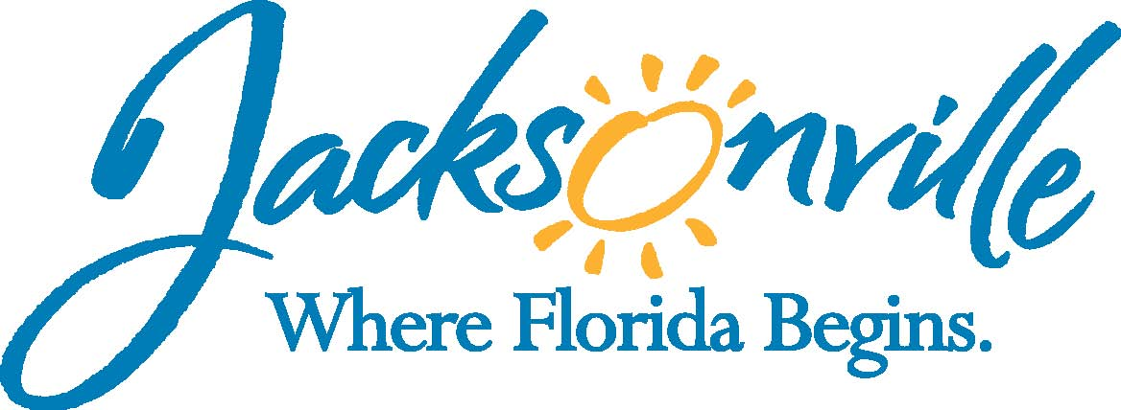

City of Jacksonville
Office Grants & Contracts Compliance
Public Service Grant Council
Application Oral Presentations

Ed Ball Building, 8th Floor, Room 851

Wednesday, May 22, 2015 11:00 a.m.
PSG Chair: Roshanda Jackson

Public Service Grant Council Member Attendance
X | Roshanda Jackson, Chair | E | Lois Salaun
E | Melissa Adams, Vice Chair | X | Autumn Tomas
 | N/A, City Council | E | Iris Young
X | Lawsikia Hodges, General Counsel | X | Chris Rose
E | Kevin Monahan | X | Dorrell Briscoe
Quorum Present: No
Staff: John Snyder

- Welcome & Introduction of PSG Council Members – Roshanda Jackson
The Public Service Grant Council (hereinafter “PSGC”) Application Oral Presentation meeting was called to order by Ms. Roshanda Jackson, Chair at 11:12 a.m. The PSG Council members and staff introduced themselves.

- Approval of Meeting Minutes from March 11, May 11th, & May 12th – Roshanda Jackson
No minutes could be approved since there was no quorum; however, there were corrections to the minutes.

- FY 2015-16 PSG Application Deadlines - John Snyder
- PSG Council Members Provided Scores to Staff: May 4, 2015

- Funding Recommendations Due to Mayor’s Office and
City Council (via letter): June 1, 2015
Mr. Snyder went over the due dates for the scores. He also discussed the fact that 6 applications did not meet the recommendations of the PSG Council and thus sought an opinion from OGC. After a review and some discussion from OGC, 4 out of the 6 applications were determined eligible for scoring. The Office of Grants and Compliance then forward this legal opinion and asked those members to score those applications in addition to the other applications.

Ms. Jackson then asked for commits from the floor seeing none she then moved to notify the audience that they have not received all the scores and therefore no action can be taken at this time and will have to skip items IV & V.

- FY 2015-16 PSG Funding Distribution Explanation - John Snyder/ Sandra Stockwell
No Action taken

- PSG Council – Discuss on Funding Recommendations – Roshanda Jackson
No Action taken

- Public Comment on Funding Recommendations - Roshanda Jackson
Ms. Maddox with Vision Is Priceless asked for the new dead line. Ms. Jackson then stated that the new dead line would be 1:00 PM this afternoon. She then recommended that she could score or other members would like to help score those applications.

Ms. Maddox asked if she could see scores and Ms. Jackson stated that the low-Income, Homeless, and Adult categories have not been finalized yet.

Ms. Tomas, and Mr. Rose stated that they would help score the remaining applications. Mr. Briscoe stated he already scored all the application and that the council could use his scores for those missing scores.

Ms. Hodges then asked if this was more of a contingency plan stating that if one member already scored these application, but just has not turn them in that would hate these members to do extra work.

Ms. Jackson then asked Mr. Snyder to notify them by 1:00 PM if the other member has not turned in their scores. Ms. Hodges stated she will contact the member because it is safer course to use this members score.

Mr. Snyder then notified the PSG Council Members of the availability of the conference room.

The members present then decided to reschedule the meeting for Wednesday, May 27, 2015 at 8:00 AM.

- PSG Council Vote of FY 2016 Funding Recommendation Order – Roshanda Jackson
No Action taken

- PSG 2nd Quarter Report to Finance Committee – John Snyder
No Action taken

- Public Comments (Please fill out a card if you wish to speak on a topic that isn’t on the agenda)

- Adjourn Meeting was adjourned at 11:45 PM

Recorder: John Snyder
    - Completed – 05/26/2015
The written minutes for this meeting are only an overview. A verbatim audio recording is available upon request.

