INTRA-GOVERNMENTAL SERVICES

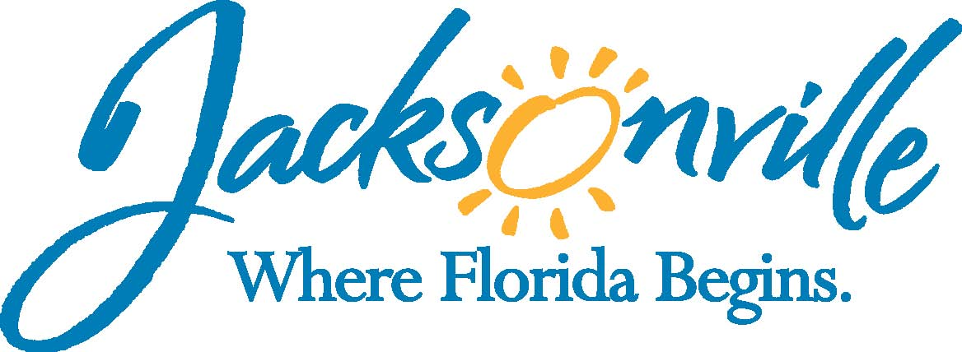

City of Jacksonville
Office Grants & Contracts Compliance
Public Service Grant Council Meeting Minutes

Ed Ball Building, 8th Floor, Room 851

Wednesday, January 14, 2015 11:00 a.m.
PSG Chair: Roshanda Jackson

Public Service Grant Council Member Attendance
E | Roshanda Jackson, Chair | X | Lois Salaun
X | Melissa Adams, Vice Chair | X | Autumn Tomas
 | N/A, City Council | E | Tiffany Wells
X | Sandra Stockwell, General Counsel | X | Iris Young
E | Patricia Andrews | X | Chris Rose-via phone
E | Radwan Chowdhury | X | Dorrell Briscoe
X | Kevin Monahan
Quorum Present: Yes
Staff: John Snyder
- Welcome & Introduction of PSG Council Members – Ms. Adams
The Public Service Grant Council (hereinafter “PSGC”) meeting was called to order by Ms. Melissa Adams, Vice-Chair at 11:25 a.m. The PSG Council members and staff introduced themselves.

- Public Service Grant Council Meeting Minutes Approval- Ms. Jackson
Ms. Stockwell asked to make changes in the minutes changing the word letter to Legislation in three places. The revised minutes from PSGC meeting on December 16, 2014 were motioned by Mr. Monahan seconded by Ms. Tomas and passed unanimously.

- PSG Council Resignation
Ms. Adams announced that Mr. Andrew Russell has resigned from the PSG Council. She added that any other members who might be considering resigning to wait until after the next rounds of PSG grading.

- Old Business
  - Ordinance Subcommittee– Mr. Rose/ Ms. Adams
Ms. Adams went over the goals of the Sub-Committee as well as meeting with several City Council members and engaging the non-profit sector with any changes to Chapter 118. Mr. Snyder added that the meeting is a posted meeting and will be open to public. He stated the time and location of the meeting.
  - PSG FY 2016 Calendar – John Snyder
Mr. Adams stated that the PSG FY 16 calendar is in all members packet for their review.

- Priority Population Legislation – Ms. Stockwell
Ms. Stockwell stated that the Ordinance 2015-34 was filed on January 7th. She will correct a typo. The definitions, and Ms. Jackson letter are attached as exhibits. She also spoke about the overfunding issue and read that paragraph. She stated that the application in the last exhibit is a place holder pending Mr. Snyder sending her the updated PSG Application & Score Sheet upon any revisions today.

She then stated that there will be a public hearing January 27th with the full council and then the committees will begin discussion the first week in February at which time it is advisable that as many members attend as possible. If approved, then City Council should take it up February 10th.

Mr. Snyder stated that once approved by City Council, he will send out e-mails and post on web-site. He will also have an application training the last week in February or the first week in March.

Ms. Adams asked Mr. Snyder to let everyone know the Committees that will be reviewing the bill. Mr. Snyder stated that Ms. Jackson will do any presentation, but he encourages as many members as possible to attend. He also stated that it important to meet with members before that week in February.

Ms. Stockwell spoke about how the Children’s Commission tried to do what we are suggesting but was denied by City Council.

- PSG Application & Scoring Sheet – Ms. Adams
Ms. Adams decided and the members agreed to go through the revised application from December’s 10th meeting. Members and attendees from Vision Is Priceless, and I M Sulzbacher, had discussions on a number of questions.

PSGC then voted and approved the following changes;
- Eliminate the word “well” from question 3 under Section III (A)
- Combine questions 4 & 7 under Section III (A) to read as follows; List your goals and objectives for last year’s program, if applicable were program goals achieved?
- Remove question 9 under Section III (A)
- Reword question 1 under Section III (C) to read as follows; Provide FY 2015 PSG Unit Cost Formula based only on PSG Funds (for example, # of clients served, # of meals served, time spent with client, etc.,)

Ms. Stockwell stated that none of these changes conflicts with 118.806.
The revised 2016 PSG Application & Scoring Sheet passed unanimously and Ms. Stockwell stated that she will include them in the Ordinance once Mr. Snyder makes the changes.

- PSG Application Criteria & Guidelines – Mr. Snyder
PSGC reviewed the Public Service Grant Application Guidelines and approved the same criteria as last year to include;
  - Only 1 application per Priority Population per agency
  - Maximum award of $125,000 per PSG grant
  - Each app graded by 6 members (PSG Chair grants all)

Ms. Stockwell stated that since March 15, 2015 falls on Sunday, then the deadline will be 11:59 PM, March 16th.

- Open Discussion
Ms. Salaun went over the scoring criteria and talked about how there is parity especially since the highest and lowest score is dropped.

- Public Commits
None

- Adjourn - Meeting was adjourned at 1:35 PM

Recorder: John Snyder
    - Completed – 01/26/2015
The written minutes for this meeting are only an overview. A verbatim audio recording is available upon request.

