INTRA-GOVERNMENTAL SERVICES

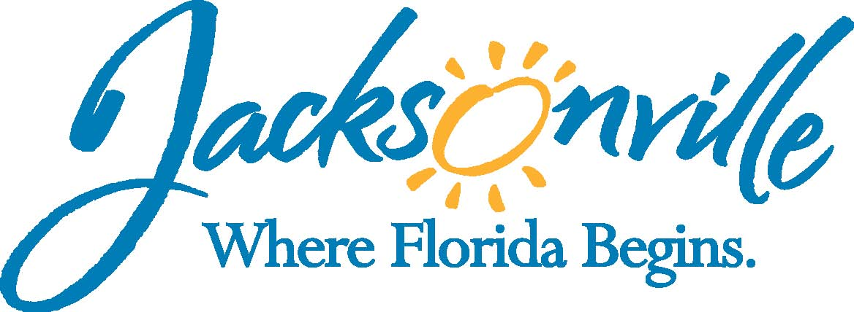

City of Jacksonville
Office Grants & Contracts Compliance
Public Service Grant Council Meeting Minutes

Ed Ball Building, 8th Floor, Room 851

Wednesday, September 10, 2014 11:00 a.m.
PSG Chair: Roshanda Jackson

Public Service Grant Council Member Attendance
X | Roshanda Jackson, Chair | E | Lois Salaun
X | Melissa Adams, Vice Chair | E | Autumn Tomas
E | Doyle Carter, City Council | X | Tiffany Wells
X | Sandra Stockwell, General Counsel | E | Iris Young
E | Patricia Andrews | X | Chris Rose
X | Radwan Chowdhury | X | Andrew Russell
X | Kevin Monahan
Quorum Present: Yes
Staff: Thomas Waters, and John Snyder

- Welcome & Introduction of PSG Council Members
The Public Service Grant Council (hereinafter “PSGC”) meeting was called to order by Roshanda Jackson, Chair at 11:06 a.m. The PSG Council members introduced themselves.

- Public Service Grant Council Meeting minutes
Mr. Monahan moved that the minutes from the 8/13/2014 meeting be approved, Mr. Chowdhury seconded the motion and the minutes were approved. Mr. Snyder pointed out these minutes are detailed to allowed members to review comments from the requested agencies for the Priority Population discussion at the next meeting.

- Budget Update – John Snyder
Mr. Snyder went over the proposed budget recommendations from the Finance Committee. This included 2% across the board cuts as well as reduced hours for Part-Time Temporary Employees, 3 Fire stations, and 80 JSO personnel. Mr. Snyder reiterated this is just the recommendation and final approved budget will not be made until September 23rd and that several members already spoke at the City Council meeting on Monday 22nd.

Ms. Jackson asked for comments from PSG Council and since there were none, she asked if anyone had comments from the audience.

Mr. Stassi with The Salvation Army asked for clarification and if there is any risk that City Council can choose not to fund PSG or any agency. Mr. Snyder indicated that it will more than likely be just an across the board cut to funding.

As a note: City Council did not cut 2% across the board and recommended funding the agencies according to PSG Council scoring for FY 2015.

- 3rd Quarter Report – John Snyder
Mr. Snyder presented the 3rd quarter PSG report to City Council. There was some discussion regarding the wording on the last sentence to read. “PSG dollars are used to leverage other services and funds; however, these numbers represent the actual services provided with PSG funds only.” There were no other changes and Ms. Adams moved to accept and Mr. Monahan seconded the motion. Motion passed unanimously.

- Non-Profit Orientation Workshop - Ms. Jackson/ Robert White (Non-Profit Center)
Mr. Bob White conducted a non-profit workshop (see Mr. Whites Outline and notes from meeting).
- Introduction of PSG Council Members & Staff
- Ice Breaking Exercise
- PSG Council Survey
- Review Chapter 118 (What PSGC must do)
- Review of PSGC Advocacy Packet
- Who do you know, who can you talk to, & what can you say to them
  - Need for more money
  - Proactive on application issue
  - Like to change the Ordinance
- Who can you visit with?
- PSG Council questions

- Open Discussion- None

- Public Comments- None

- Adjourn - Meeting was adjourned at 1:56 PM
Recorder: John Snyder
    - Completed – 10/02/2014
The written minutes for this meeting are only an overview. A verbatim audio recording is available upon request.

