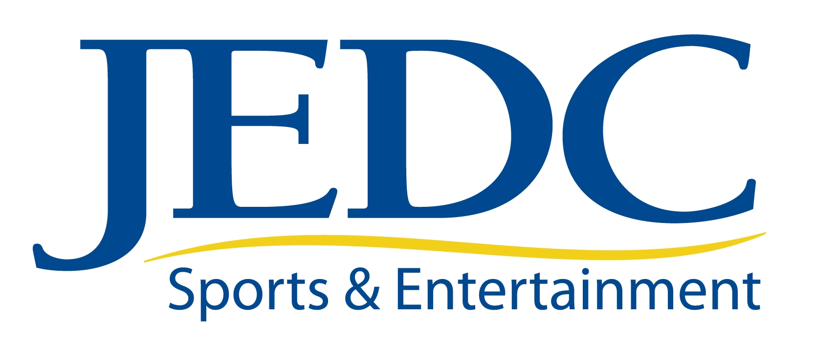
Jacksonville Sports & Entertainment Board
Board Meeting
Tuesday, June 29, 2010
8:30 a.m.

Agenda

- Call to Order Michael Munz
- Present and Future Events Michael Bouda
  - 2010 GA/FL Football:
    - Hall of Fame
    - Additional Activities
  - Lacrosse Update- Tagline Ideas
  - Tyson American Cup Update
- Facilities Michael Bouda
- Future Event Ideas Michael Bouda
- Sponsorships Michael Bouda
- Re-Do Sports and Entertainment Website Michael Bouda
- Jaguar Outreach Michael Munz
- Ad Hoc Members (Non-Voting) Michael Munz
- Future Meetings Michael Munz
- Adjournment Michael Munz

