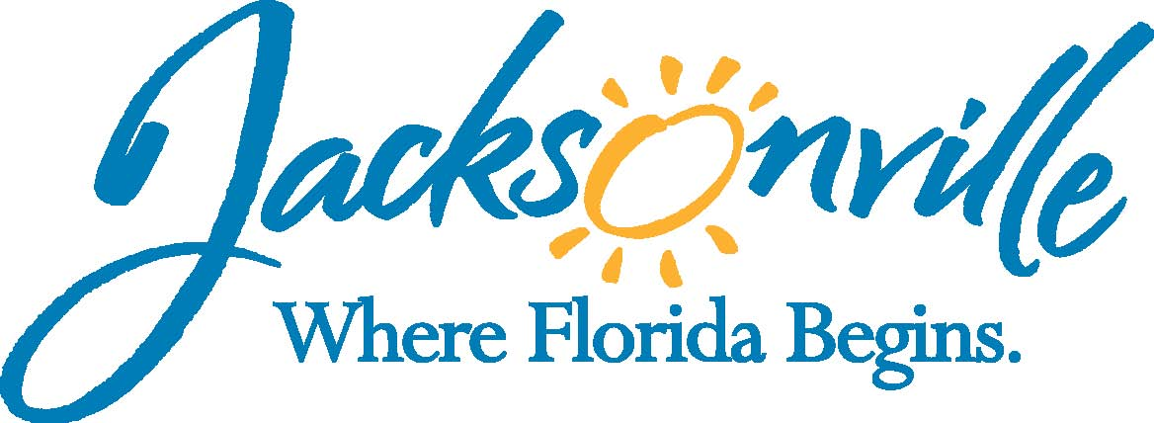
notice

Meeting

The Public Service Grant Council of the City of Jacksonville will meet on the Tuesday, February 16, 2010 at 10:00 a.m. to discuss Public Service Grant business. The meeting will be held at the Ed Ball Building, 214 North Hogan Street, 8th Floor Meeting Room. This meeting is open to the public and members of the public are invited to attend.

If a person decides to appeal any decision made by the Public Service Grant Council of the City of Jacksonville, with respect to any matter considered at this meeting, that person will need a record of the proceedings, and that for such purpose, that person may need to ensure that a verbatim record of the proceedings is made, which record includes the testimony and evidence upon which the appeal is to be based. Fla. Stat. Sec. 286.0105(2007).

For More Information, call 630-2099

